How to Create a Zoom-In-Inquiry Activity

A Zoom-In-Inquiry Activity is created in a presentation program, usually PowerPoint or Google Slides, and allows for the teacher to guide students in uncovering a primary source image in small pieces. This is a great way to introduce new lessons with investigation and differentiation.

Google Slides Instructions

PowerPoint Instructions

The power of this activity rests in the ability to crop out sections of the image or primary source document to guide student’s learning. As sections of the primary source are revealed, students discover new observations, reflections, and questions through their own inquiry process, acting as detectives for their own learning.

Tips for Ensuring a Powerful Learning Experience
The best primary source will speak for itself, so it is important to keep your eye out for specific things when you select one. This activity can be done with any type of viewable primary sources, for example, maps, photos, text, historic newspapers, and more!

Here are some general key things to consider:
- Choose a primary source that has a lot of different things in it, rather than just a portrait with no background. For example, choose a picture that has a setting, objects, individuals and animals, activities, and text.
- Crop your picture into interesting sections that spawn curiosity. For example, only include the hat or shoes of the subject in the first slide and expand from there. Or, for a document, only include the last sentence.
- When adding questions for your students, consider adding questions you may not think be relevant. For example, What do you think it smelled or sounded like in the image? Why was the picture taken? What is left out? If the picture was taken from a different angle, how would it change your perception of it?
- You can make it as simple or as advanced as you’d like. For example: Crop the image 6 times instead of 4; Integrate more than one image; Use a map instead of an image.

Hint: Hide the most important part of the document until the very end so that students’ curiosity
drives their thinking through the inquiry process.

Google Slide Instructions
These are instructions for creating a Zoom-In-Inquiry Activity with Google Slides.

Step 1:
To get started, open a Google Slides presentation where you want to enter the Zoom-In-Inquiry Activity and create a blank slide.

Next, insert an image into that slide by clicking on Insert >>> Image >>> Upload from computer. Select the image and resize it to your liking by dragging and dropping the blue corner dots.

Step 2:
Next, duplicate this slide for as many times as you plan on cropping the picture. For example, if you want to crop the image in 4 sections, duplicate the slide 4 times. This ensures the image stays in the same place for all of the slides no matter where you decide to crop it.

To do this, right click on the slide you want to duplicate, and click Duplicate Slide.

Step 3:
Go back to the first slide where you want to crop. Right click on the image and select Crop image.

From here you can crop the image by dragging and dropping the black corners of the image to the desired portion that you wish the students to see first. Click Enter when you are satisfied.

Step 4:
Crop each image on the following slides to the desired portions by repeating Step 3 above.

Hint: When you crop the images, reveal a new portion of the image each time so that students will find out more about it as it slowly reveals itself.

Step 5:
After you have cropped all of your images on the individual slides, you can add in text to help guide students in the inquiry process. For example, add in guiding questions, bibliographic information, context, and/or hints.

PowerPoint Instructions
These are instructions for creating a Zoom-In Inquiry Activity with Adobe PowerPoint.

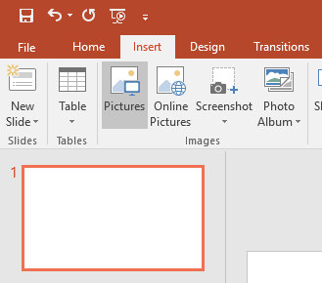
Step 1:
To get started, open a PowerPoint presentation where you want to enter the Zoom-In-Inquiry Activity and create a blank slide.

Next, insert an image into that slide by clicking on the Insert tab at the top left and then Pictures. Select the image from your computer and resize it to your liking by dragging and dropping the corner dots.

Step 2:
Next, duplicate this slide for as many times as you plan on cropping the picture. For example, if you want to crop the image in 4 sections, duplicate the slide 4 times. This ensures the image stays in the same place for all of the slides no matter where you decide to crop it.

To do this, right click on the slide you want to duplicate, and click Duplicate Slide.

Step 3:
Go back to the first slide where you want to crop.

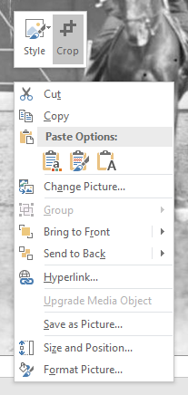
Select the image you want to crop and the Format tab will appear. On the Format tab, click the Crop command in the upper right corner of the menu. 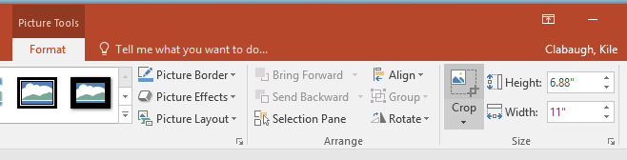

You can also right click on the image and the click Crop.

From here you can crop the image by dragging and dropping the black corners of the image to the desired portion that you wish the students to see first. Click Enter when you are satisfied.

Step 4:
Crop each image on the following slides to the desired portions by repeating Step 3 above.

Hint: When you crop the images, reveal a new portion of the image each time so that students will find out more about it as it slowly reveals itself.

Step 5:
After you have cropped all of your images on the individual slides, you can add in text to help guide students in the inquiry process. For example, add in guiding questions, bibliographic information, context, and/or hints.

