Name: _____________________________ Date: _________________

Standards Implementation
Module #6: Making Connections

Goals & Objectives:
Educators will be able to demonstrate their understanding of the following through writing and discussion:
- Delineate which statements regarding Colorado Academic Standards are fact or fiction;
- Examine the relationship across text features of the 2020 Colorado Academic Standards (CAS) document; and
- Make connections and understand how all text features work together to form the standards.

Disciplinary Literacy Strategies:
- “Writing in discipline-specific ways”
- Speaking for understanding in content-areas
- Reading from the lens/perspective of a subject/content area

Myth Buster Warm-up: Are the statements below True or False? Place a ☑ or a ☒ to indicate your answer.

 | Statements | True | False
1. | Common Core State Standards are the same as Colorado Academic Standards
2. | Colorado’s adoption of the Common Core State Standards means there’s tight alignment between the Grade-Level Expectations and Evidence Outcomes for Math and Reading, Writing, and Communicating, but the additional Academic Contexts and Connections section found in Colorado’s standards aren’t found in the Common Core State Standards.
3. | There are power standards, so some are more important than others. With that said, it is best practice to focus on the power standards (i.e., those repeated from grades P-12 and heavily tested on CMAS, PSAT, Accuplacer, and SAT) and let go of the supplemental standards.
4. | The standards represent Colorado’s requirements for graduation. Students must demonstrate mastery of them, specifically the skills, concepts, and content in the Prepared Graduate Statements and Grade-Level Expectations in order to graduate.
5. | Colorado’s state-level graduation requirements are represented by the graduation guidelines, not standards. However, standards are “the academic bar” that determines what students must know, understand, and be able to do. Students who can demonstrate the skills, concepts, and content within standards are better prepared to participate and compete in college and the workforce.
6. | The Evidence Outcomes in the Colorado Academic Standards can be made into a checklist to cover them as learning goals (e.g., using one Evidence Outcome per lesson or creating a rubric using the Evidence Outcomes).
7. | The Evidence Outcomes are just a few examples of students demonstrating mastery, but are not required.

I. What are the three design principles for the CAS?

1
2
3

II. Circle the correct answer in reference to the displayed CAS sample document

Which of the following feature(s)/element(s) is considered the actual standard?

  - Prepared Graduate Statement
  - Grade Level Expectation
  - Evidence Outcomes
  - Academic Context and Connections
  - A, B, and C
  - All of the above

III. Common Revisions Applicable to All Content Area Standards:

- __________________________________________________________________________
- __________________________________________________________________________
- __________________________________________________________________________

IV. Table Group Discussion and Gallery Walk
- In your table groups discuss and chart your responses to the following questions:

- What are the explicit connections between the Evidence Outcomes, Grade Level Expectations, and Academic Context and Connections?

- How do the concepts, content, and skills in section of standards page work together to ensure student success in college, a career and life?

Gallery Walk
- What similarities do you see among group responses?

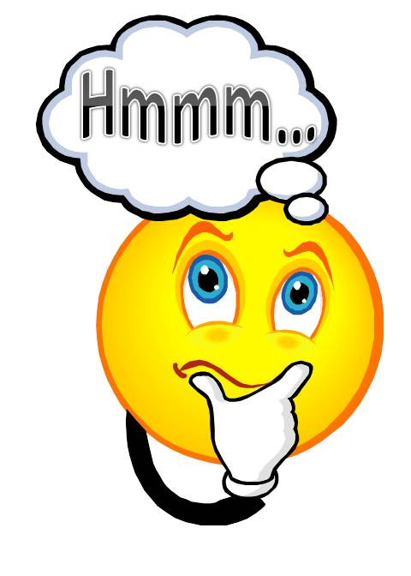 B. Which responses provoke further question/discussion?

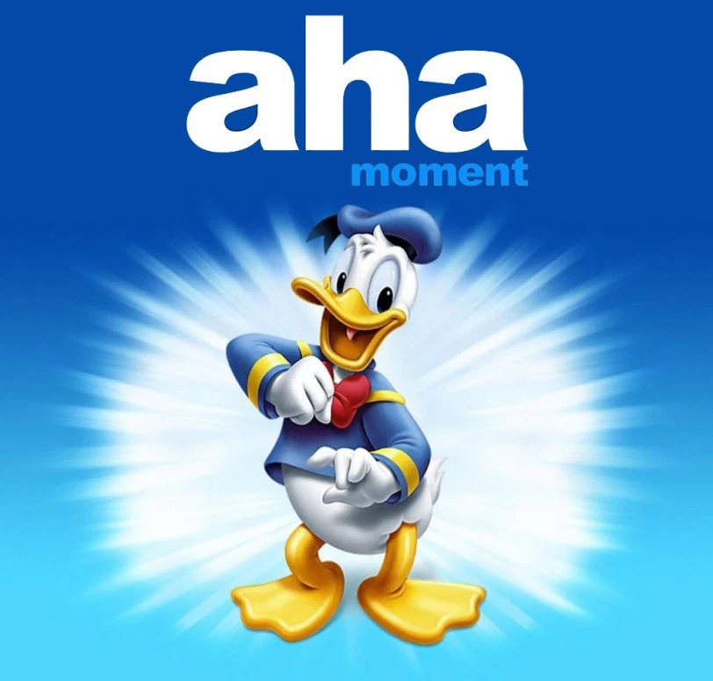
C. Which responses created an Aha moment?

V. Synthesis
How do you envision using the entire standards page within your curricular planning?
________________________________________________________________________________________________________________________________________________________________________________________________________________________________________________________________________________________________________________________________________________________________________________________________________________________________________________________________________________________________________________________________________________________________________________________________________________

VI. Reflection
Now that you have completed the first 6 modules . . .
- What is one learning you will take away?
- What is one question you still have regarding standards?
- What do you hope will be covered over the next 8 modules? Your voice matters! To ensure the next round of modules meet the needs of educators, please email all feedback to the standards and instructional support team members here: http://www.cde.state.co.us/standardsandinstruction/contact

