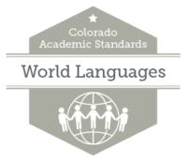What to Look for in the 2018 World Language Revision

Improve Clarity and Alignment for the Discipline of World Languages

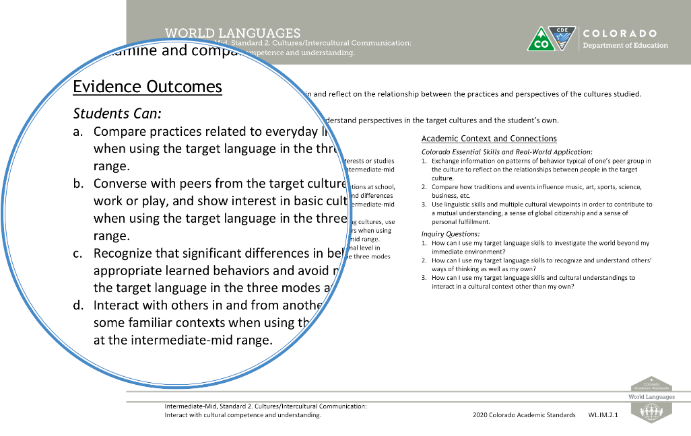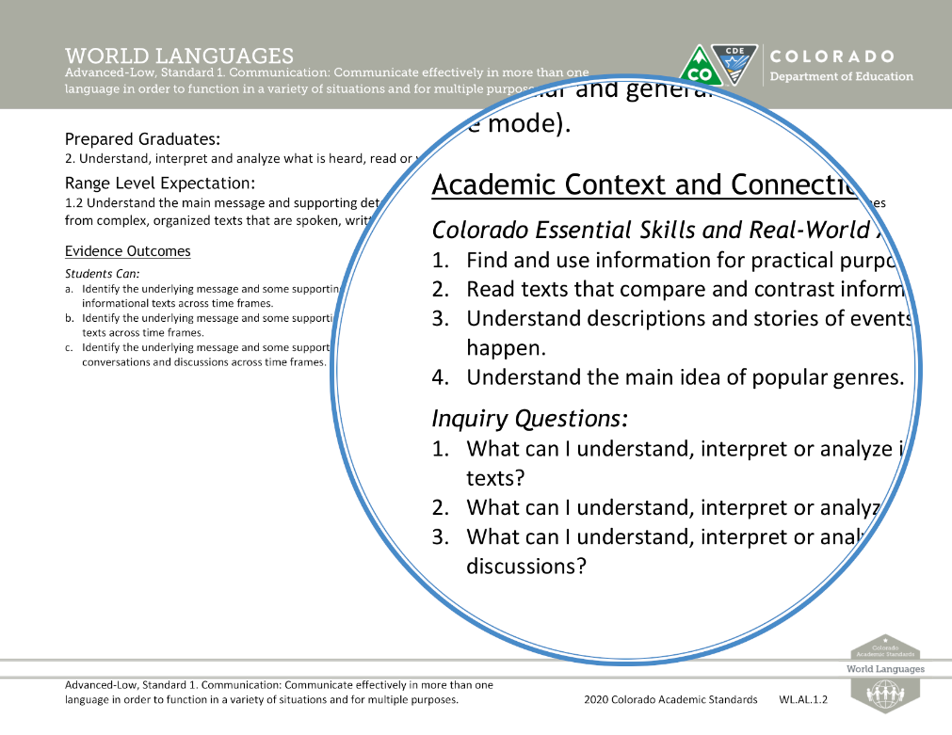

The 2009/2010 World Language Standards organized content into 4 main standards: Communication, Cultures, Connections and Comparisons. Within these standards conceptual learning was organized as evidence outcomes (EOs) under range level expectations (RLEs). In the 2020 Revised World Language Standards Cultures is revised to Cultures – Intercultural Communication.

Language under the Evidence Outcomes are revised to align with the NCSSFL – ACTFL Can-Do Statements to provide key components that define the range level expectation.

The 21st Century Skills and Readiness Competencies was revised to the section of Academic Context and Connections in order to capture the unique elements of language learning to create context for learning. These 2 sections highlight essential skills, practices and other important connections necessary for student to understand, apply and transfer the Range Level Expectations.

This section includes Colorado Essential Skills and Real-World Application. The Colorado Essential Skills and Real World Application captures the usage of language that go beyond the classroom in producing global citizens for the ongoing demands of a workforce and post-secondary readiness.

Inquiry Questions were revised to better align with the NCCSSFL – ACTFL Can-Do Statements to promote goal setting and analysis of student learning within the range level expectation.

What to Look for in the 2018 World Language Revision

Wider Range of Proficiency Levels

The 2009/2010 World Language Standards Proficiency Range ended at the Intermediate-Mid.

Guided by public feedback, there was a lack of a continuum of proficiency levels for language development. These issues were cited in a benchmarking report performed by the American Council on the Teaching of Foreign Languages, ACTFL. The 2018 Review and Revision Committee reorganized the standards into a longer range of proficiency levels and included all 4 standards making it optimal for language development. The Review and Revision Committee also clarified the language throughout the revised 2020 standards in the new proficiency range.

The newest development of World Language Standards Range Levels includes Preschool, Intermediate-High, and Advanced-Low – now offering a complete spectrum allowing multiple entries and exit points for language learning and teaching.

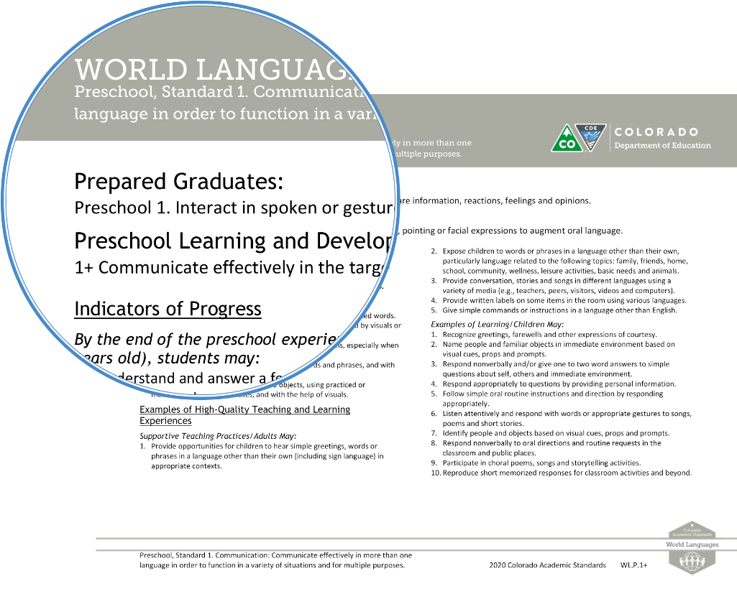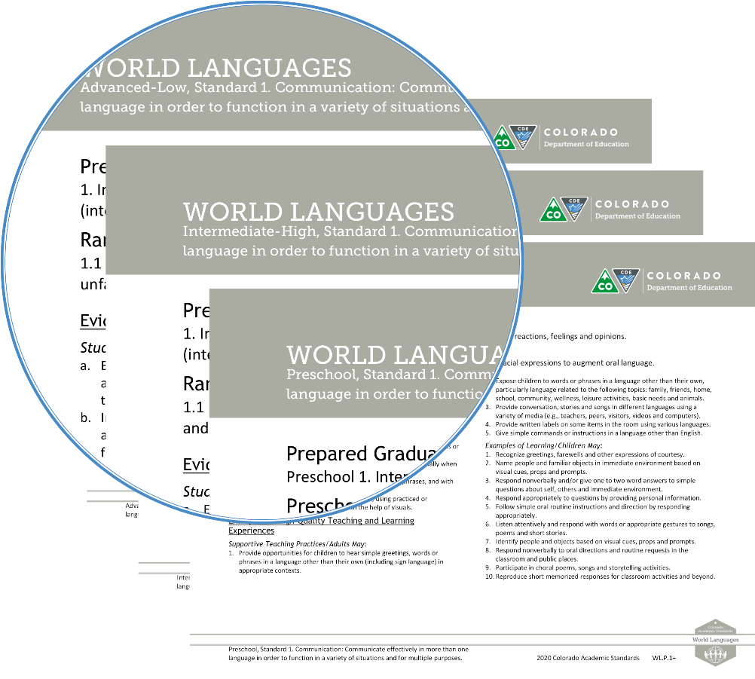

Preschool Standards are all encompassing of all elements of the 4 standards. For Example: Standard 1 Communication, element 1.1, 1.2 and 1.3 are all in one element in the Preschool standard labeled 1+. The element is encompassing all the elements appropriate for the Preschool language learner. Natural progressions for the early language learner is the Novice-Low Range Level.

Also new are Prepared Graduate statements specific for the Preschool language learner to prepare for Prepared Graduate statements beginning at Novice-Low.