  - What to Look for in the 2020 Visual Arts Revision

A Reorganization to Bring Alignment of Skills and Concepts across Grades
Clarity of language and stronger alignment of learning expectations within and across grades were a primary focus of the review and revision process. When aligning developmentally appropriate expectations within the standards, the results are deletions, revisions, and reorganization.
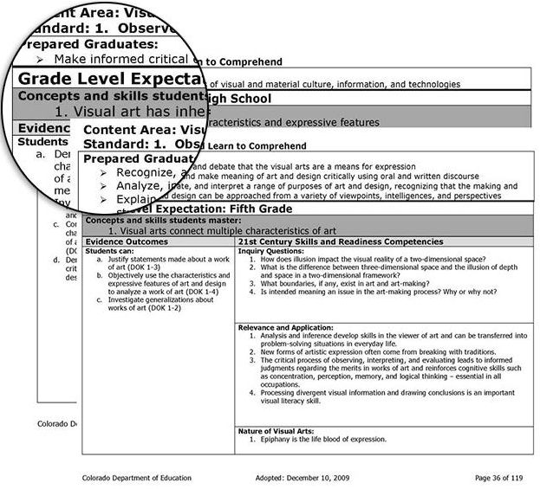
Guided by public feedback, misalignment issues cited in a benchmarking report and their own experience with the standards, the 2020 review and revision committee reorganized the standards so that concepts and skills are developmentally aligned PK-12 from the Prepared Graduate Statements to the Grade Level Expectations and the Evidence Outcomes. These changes were made to add specificity and clarity, not to fundamentally change what students are expected to learn from the 2009 visual arts standards.
For example, the 2009 High School Standard 1 GLE 1 linked to one Prepared Graduate Competency (PGC) of Make informed critical evaluations of visual and material culture, information, and technologies. However, the corresponding standard in 5th grade was linked to three different PGCs such that there was little developmental consistency in the alignment of outcomes, in particular between elementary and middle school and middle to high school.
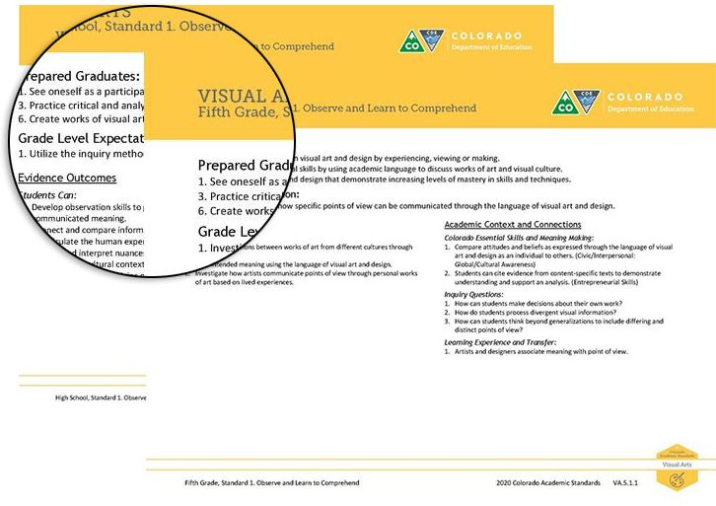
The review and revision committee for the 2020 standards aligned outcomes PK-12 for smoother transitions between grade bands for students and easier alignment for teachers who teach multiple grades in one school.

Verbs Added to Grade Level Expectations for Greater Clarity and Measurability
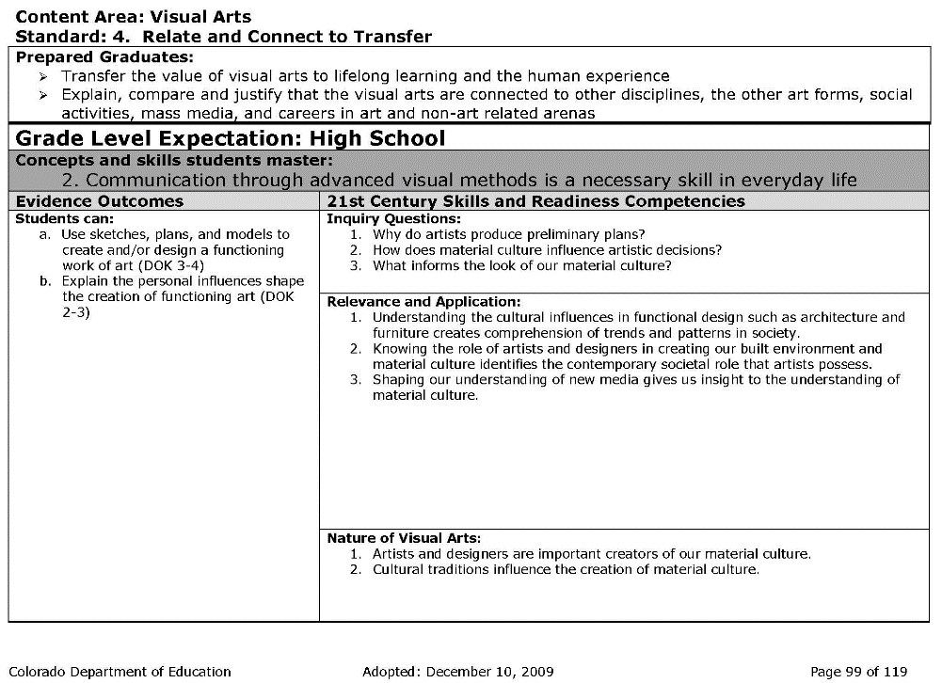
Measurable verbs were added to all Grade Level Expectations (GLEs) PK-12 and in all four visual arts standards to increase specificity and rigor. For example, the 2009 standard 4. Relate and Connect to Transfer for High School GLE 2 was a statement that was not measurable and did not explain what students should know or be able to do.
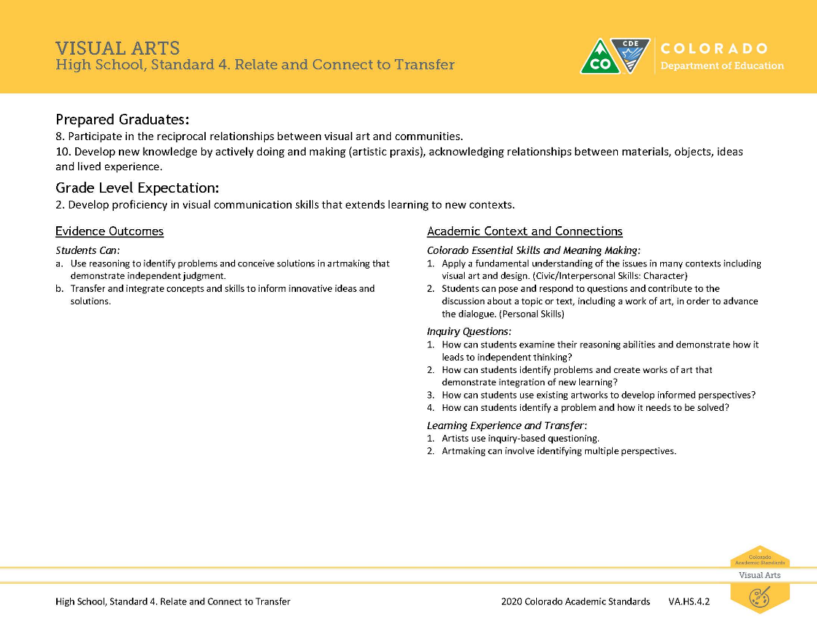
The 2020 revised standard 4. Relate and Connect to Transfer for High School GLE 2 clarifies that students should develop proficiency in visual communication skills. The revised evidence outcomes specify how this could be done.

Reducing Seventeen Prepared Graduate Statements into Ten

In the 2020 revision, the Prepared Graduate Competencies are now described as Prepared Graduate Statements. These represent concepts and skills all graduates need to be successful after high school.
2009 Prepared Graduate Competencies
- Recognize, articulate, and debate that the visual arts are a means for expression
- Make informed critical evaluations of visual and material culture, information, and technologies
- Analyze, interpret, and make meaning of art and design critically using oral and written discourse
- Explain, demonstrate, and interpret a range of purposes of art and design, recognizing that the making and study of art and design can be approached from a variety of viewpoints, intelligences, and perspectives
- Identify, compare, and interpret works of art derived from historical and cultural settings, time periods, and cultural contexts
- Identify, compare and justify that the visual arts are a way to acknowledge, exhibit and learn about the diversity of peoples, cultures and ideas
- Transfer the value of visual arts to lifelong learning and the human experience
- Explain, compare and justify that the visual arts are connected to other disciplines, the other art forms, social activities, mass media, and careers in art and non-art related arenas
- Recognize, interpret, and validate that the creative process builds on the development of ideas through a process of inquiry, discovery, and research
- Develop and build appropriate mastery in art-making skills, using traditional and new technologies and an understanding of the characteristics and expressive features of art and design
- Create works of art that articulate more sophisticated ideas, feelings, emotions, and points of view about art and design through an expanded use of media and technologies
- Recognize, compare, and affirm that the making and study of art and design can be approached from a variety of viewpoints, intelligences, and perspectives
- Recognize, demonstrate, and debate philosophic arguments about the nature of art and beauty (aesthetics)
- Recognize, demonstrate, and debate the place of art and design in history and culture
- Use specific criteria to discuss and evaluate works of art
- Critique personal work and the work of others with informed criteria
- Recognize, articulate, and implement critical thinking in the visual arts by synthesizing, evaluating, and analyzing visual information
2020 Prepared Graduate Statements
1. See oneself as a participant in visual art and design by experiencing, viewing or making.
2. Visually and/or verbally articulate how visual art and design are a means for communication.
3. Practice critical and analytical skills by using academic language to discuss works of art and visual culture.
4. Critique connections between visual art and historic and contemporary philosophies.
5. Interpret works of art and design in the contexts of varied traditions, histories and cultures.
6. Create works of visual art and design that demonstrate increasing levels of mastery in skills and techniques.
7. Allow imagination, curiosity and wonder to guide inquiry and research.
8. Participate in the reciprocal relationships between visual art and communities.
9. Persist in the creative process and innovate from failure.
10. Develop new knowledge by actively doing and making (artistic praxis), acknowledging relationships between materials, objects, ideas and lived experience.

Defining the Four Standards and how each fit in the Creative Process of Artmaking
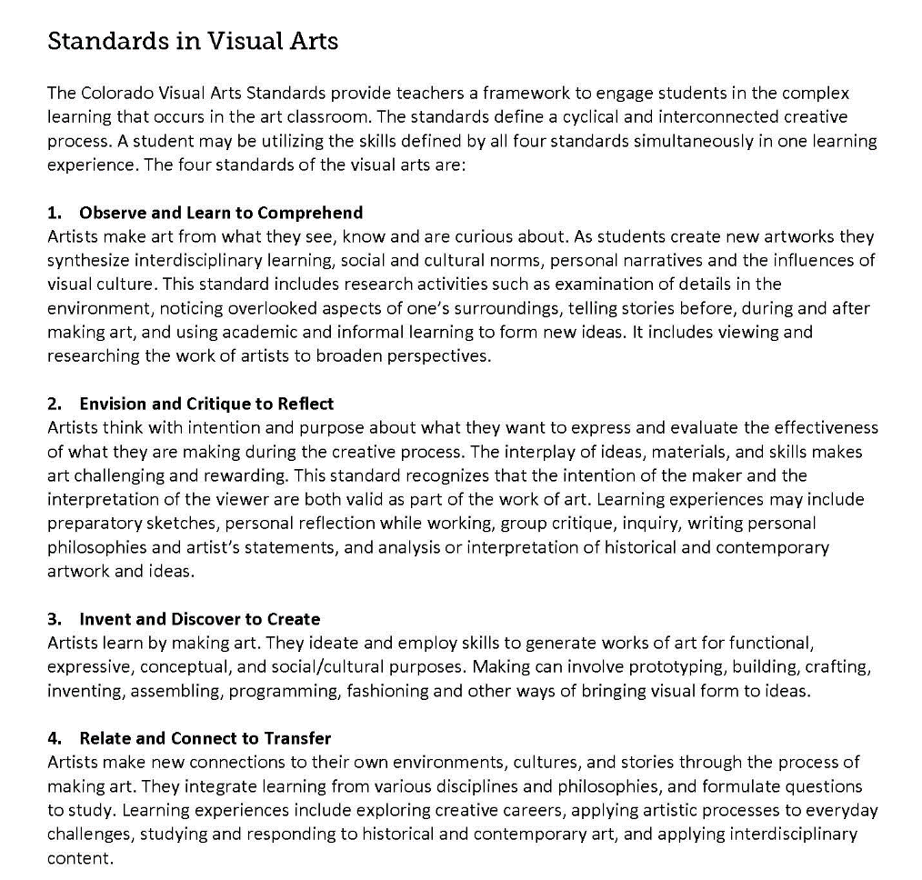
The committee of the 2020 standards re-worded the standards definition statements for greater clarity of intent declaring how creative artmaking is actively embedded throughout each of the four standards.

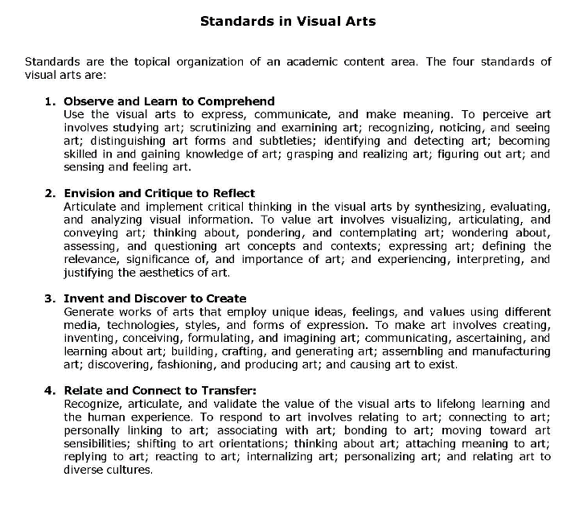
Public feedback received as well as the experience of 2020 visual arts review and revision committee indicated a need for greater clarity of the intent of the standards definitions.
Intentional use of Academic Art Vocabulary
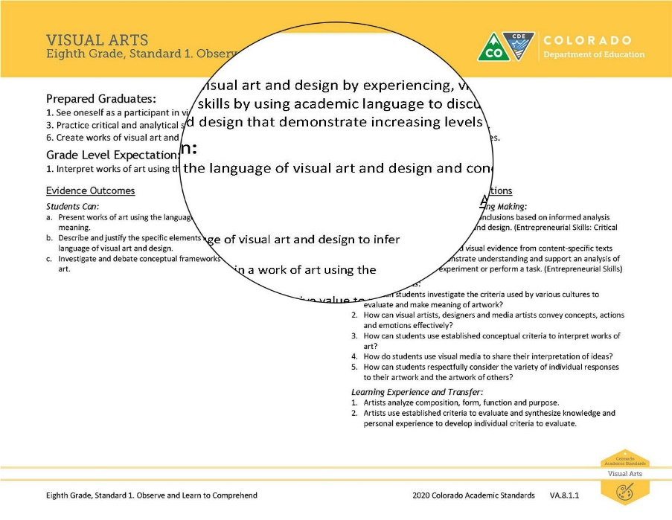
The front matter of the 2020 visual art standards clarifies and defines many of the discipline specific academic terms used in the document. There are several new additions from the 2009 standards including “language of visual art and design” which refers to the components of art that artists use when they make and talk about art. It includes the elements and principles of design used in teaching the formal qualities of artmaking, but allows for additional interpretations as may be appropriate for a particular context.

The term acknowledges that visual elements such as line, shape, color and compositional choices such as perspective, balance, rhythm and more can be an element of “text” that conveys artistic intent and meaning.

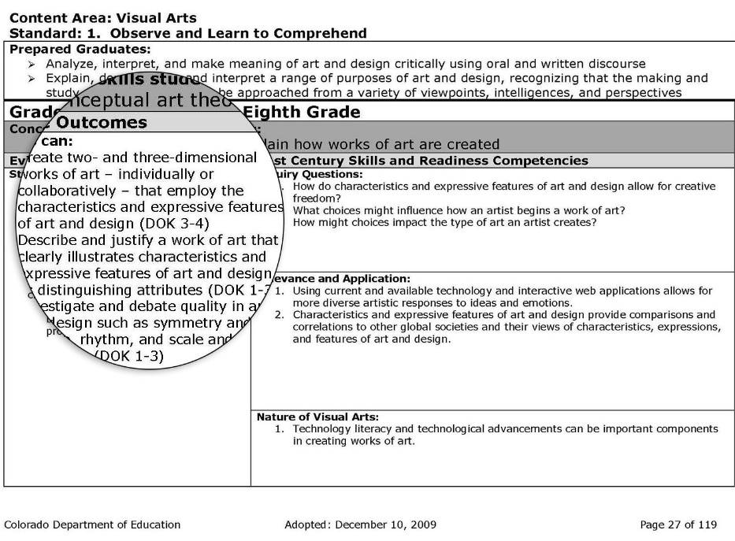
The term “language of art and design” replaces “characteristics and expressive features” of art and design used in the 2009 standards continuing to recognize multiple interpretations for addressing ways to construct and deconstruct works of art across various times and cultures.

Academic Context and Connections

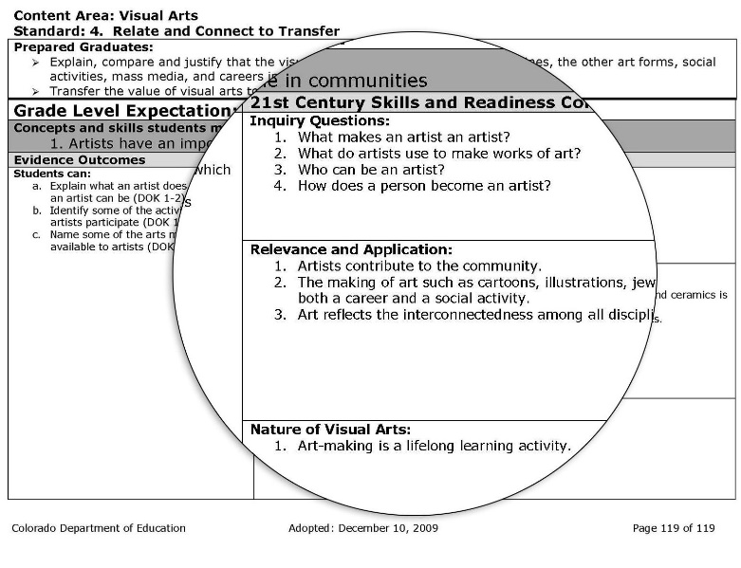
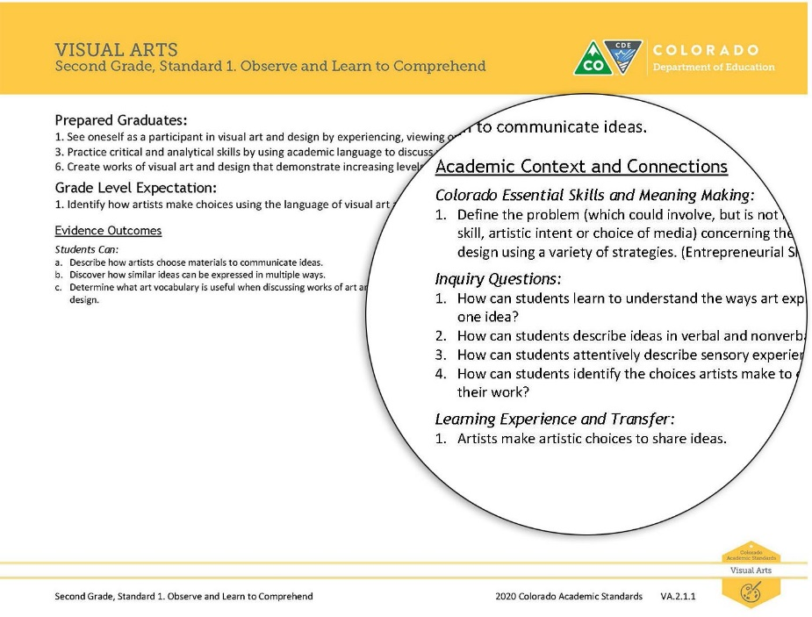
This heading Academic Context and Connections replaces 21st Century Skills and Readiness Competencies that was used on the right side of the 2009 visual art standards.
Learning Experience and Transfer
The review and revision committee replaced the 2009 Nature of Visual Arts subheading with Learning Experience and Transfer. This new subsection is designed to illustrate how the learning and experience that happens in the corresponding GLE can be used to expand student thinking, encourage conceptual curiosity and connect multiple disciplines and literacies.
Inquiry Questions
The review and revision committee kept the Inquiry Questions subheading from 2009, but made significant edits and additions. The committee designed each question to prompt deeper thinking about the visual art content described by the Grade Level Expectation and Evidence Outcomes. Inquiry Questions in the visual arts standards are phrased for a teacher to reflect on their instructional practices and their students’ learning. The questions may be rephrased to use as direct questions to students or to assist as they reflect on their own artmaking experiences.

Colorado Essential Skills and Meaning Making
This term replaces the subheading Relevance and Application in the 2009 document. Colorado Essential Skills and Meaning Making identifies ways in which students demonstrate the ability to form, grapple with and convey concepts and ideas through visual art and design compatible with critical and creative thinking found in scientific, mathematical, and other real-world applications. The last statement explains how literacy can be authentically evidenced through the corresponding Grade Level Expectation linking discipline specific literacy in artmaking to Reading, Writing, and Communicating and the Colorado Essential Skills.

Preschool
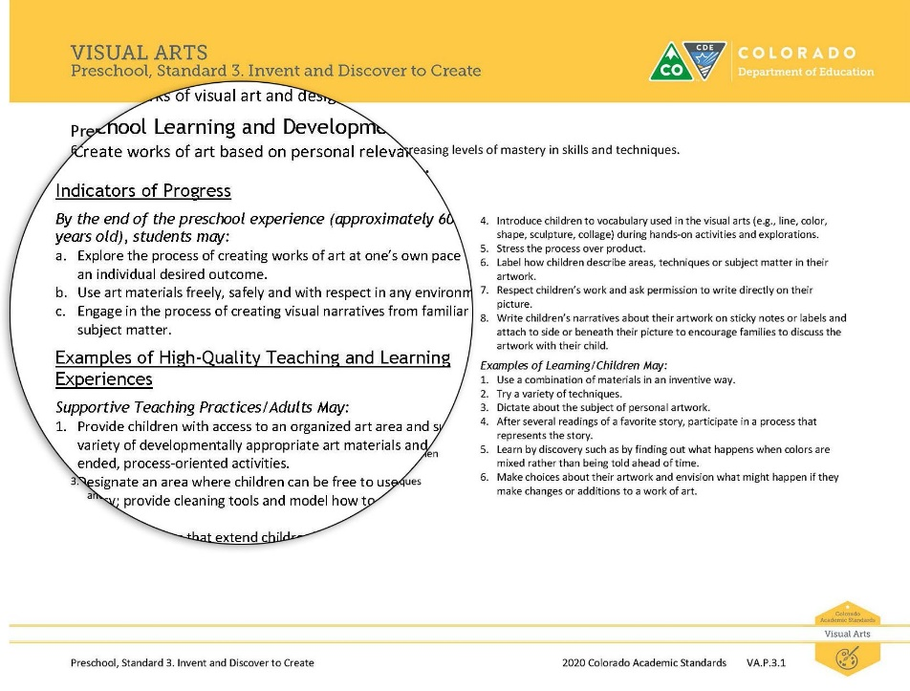
The review and revision committee’s preschool revisions are a significant change compared to the 2009 standards, but a minor adjustment when compared with CDE’s 2013 Early Learning Development Guidelines. As in the other content areas of in the 2020 standards, instead of Grade Level Expectations in preschool there are Preschool Learning and Development Expectations. Instead of Evidence Outcomes there are Indicators of Progress. Instead of Academic Context and Connections there are Examples of High Quality Teaching and Learning Experiences.

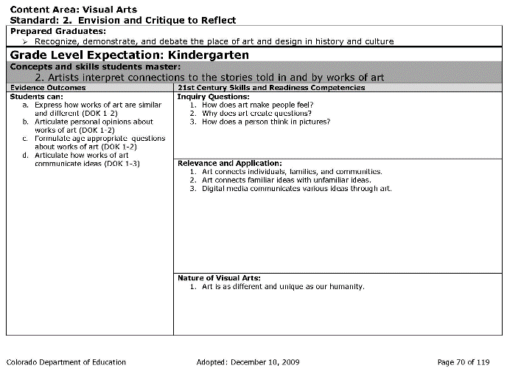
Elementary
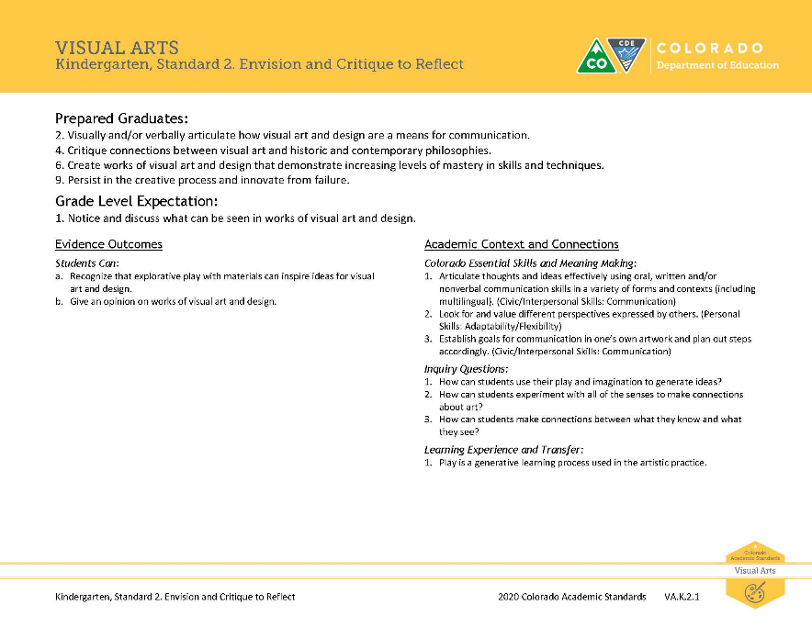
The committee combined the Grade Level Expectations (GLEs) for developmental appropriateness and to take into account the limited amount of instructional time available in elementary art schedules. The Evidence Outcomes (EOs) within the combined GLEs were streamlined for greater alignment.
For example, in the 2009 standard Kindergarten Standard 2 Relate and Connect to Transfer had two GLEs and eight Evidence Outcomes. In the 2020 revised standards it like, most other PK-3rd grade visual art standards, has one GLE and fewer EOs.

Middle School
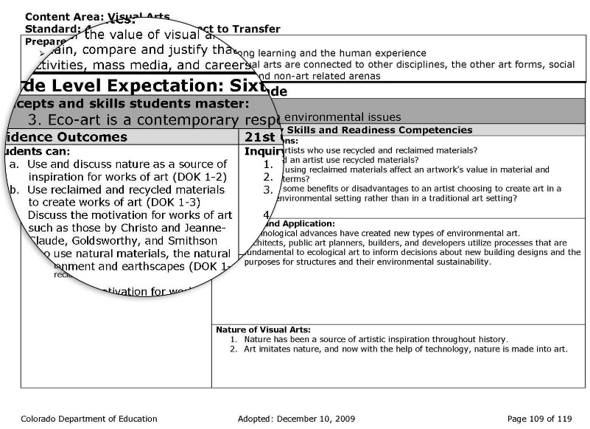
Visual art concepts and skills shifted between some GLEs to establish greater coherence, focus and alignment with research-based learning progressions for visual art. The EOs were clarified for greater alignment to the GLEs and to increase accessibility. The Relate and Connect to Transfer standard was revised be more open to the application of individual schools and districts and for greater alignment PK through HS. Content examples were provided to add clarification to some EOs. As an example, the 2009 standard 4. Relate and Connect to Transfer for 6th grade was specific to one type of art that might not meet the needs of all communities and contexts.
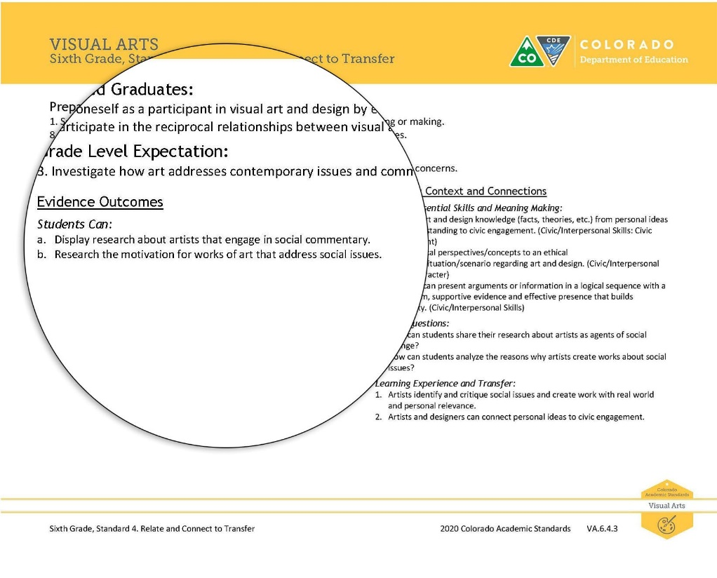
In some cases, content examples were provided to add clarification of intent. For example, the Academic Context and Connections in 7th grade standard 4. Relate and Connect to Transfer GLE 3 describes artists incorporating ideas from social and community activities.
In the 2020 revision, the same standard is much more open to district and community interpretation of appropriate curriculum while still meeting the same level of rigor in fewer Evidence Outcomes.

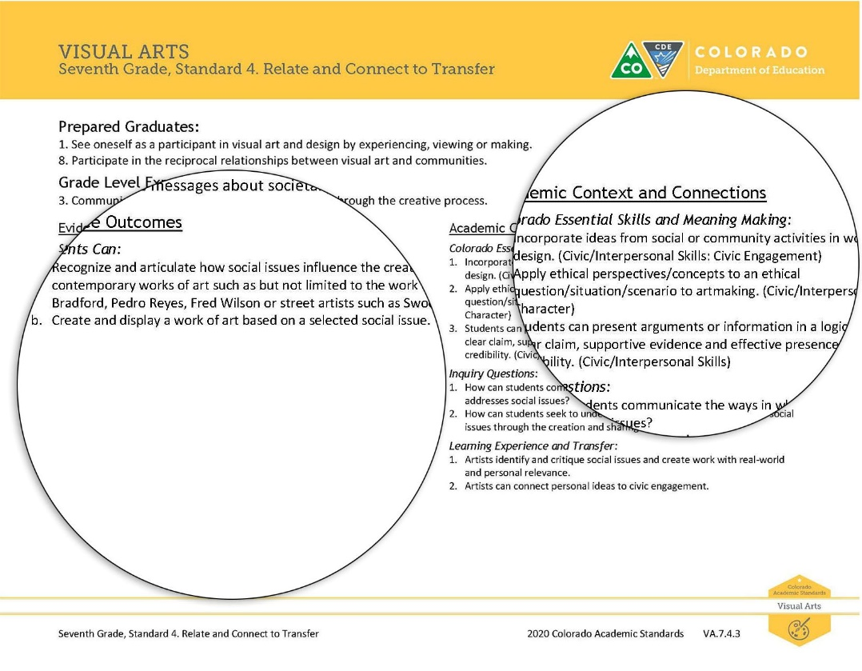
The revision committee added examples in the Evidence Outcomes of artists whose work may have exhibited this trait. This is not meant to prescribe curriculum but to offer support for teachers to determine how they might best teach this standard in ways that meet the needs of their own community, culture and context.

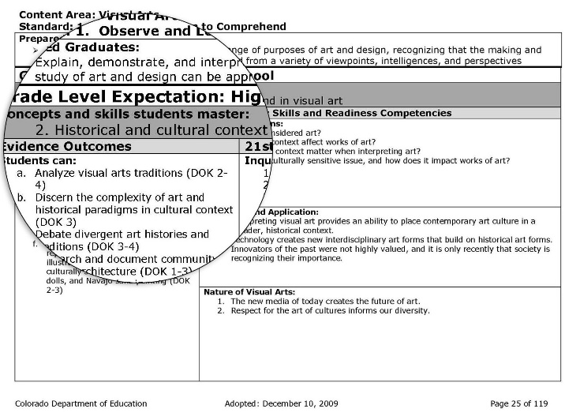
High School
The committee clarified language to better define the focus of the content and the expected outcomes. Evidence outcomes (EOs) were clarified for greater alignment to the GLEs and to increase the depth and breadth of the outcome appropriate to the HS grade band level.
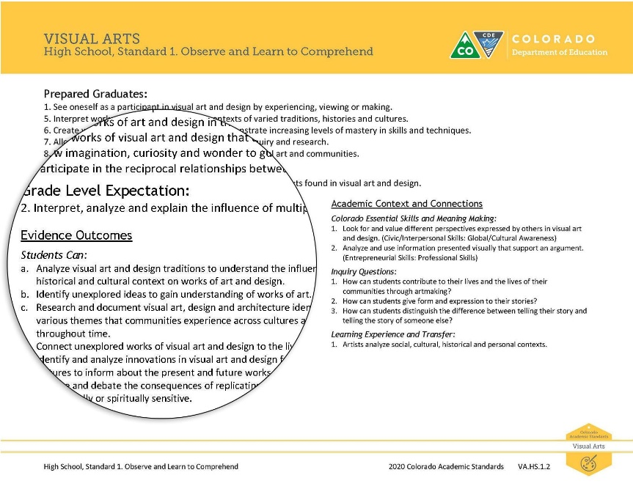
For example, in High School Standard 1. Observe and Learn to Comprehend GLE 2, the committee clarified the intent of Grade Level Expectation and the Evidence Outcomes.

