  - What to Look for in the 2020 Science Standards

A Reorganization to Bring Greater Focus to Connected Scientific Core Ideas, Science and Engineering Practices, and Cross-Cutting Concepts
through Tighter Vertical Alignment

The 2009 science standards included core ideas and nature of science statements throughout the document; however they appeared to be disconnected due to the emphasis that was placed on the evidence outcomes. In addition, there were many gaps vertically within the standards that allowed for an over emphasis of one concept, at the expense of others.
Guided by public feedback, misalignment issues cited in a benchmarking report, and their own experience with the standards, the standards review and revision committee reorganized the standards to align with the Next Generation Science Standards (NGSS) in order to place equal emphasis on the core ideas, science and engineering practices, and cross-cutting concepts, and to add greater coherence across and between grade levels. They used the research from the K-12 Framework for Science Education published by the National Academy of Sciences as their guiding document for revisions.
Adaptation of the Next Generation Science Standards (NGSS)
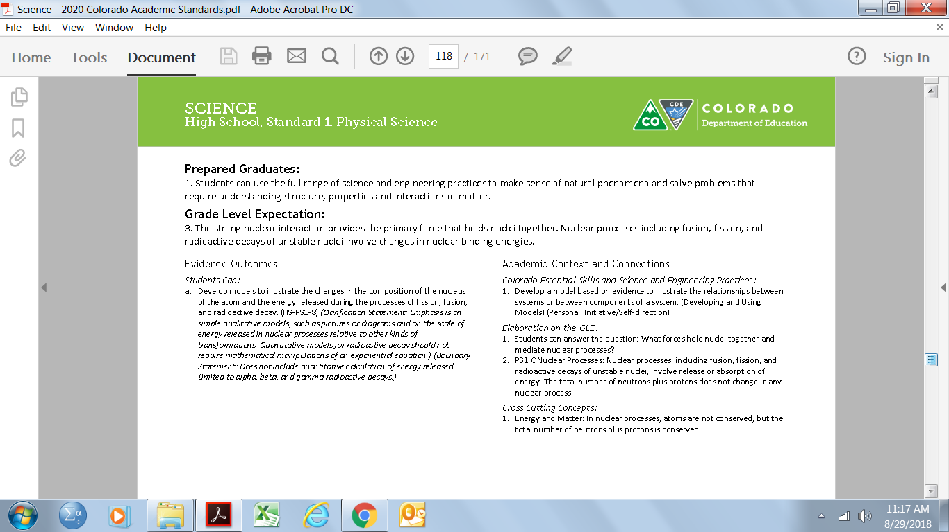
The committee decided to adapt the NGSS by not
recommending the adoption of the forth standard,
engineering, technology, and application of science;
however, they still included engineering within the
science practices. It was understood that districts
must meet or exceed state determined standards and
therefore left the decision of the forth standard
adoption up to districts at the local level. In addition,
keeping the original standards framework (Prepared
Graduate Statement-Grade Level Expectation-Evidence
Outcome), the committee wrote new Grade Level
Expectations within each standards strand (physical, life,
and earth and space sciences).
The committee added coding to the evidence outcomes to demonstrate where educators could find the same reference within the NGSS documents, which allows them to search for materials on-line by code. The code also allows educators to make connections to the core ideas within each standard.

Promoting Practices and Essential Skills
The 2009 science standards have a section titled “21st Century Skills” which house inquiry questions, relevance and application statements, and nature of sceince elements. The 2020 science standards have re-titled this section to be, “Academic Content and Connections.”
The first component of this section is the “Colorado Essential Skills and Science and Engineering Practices.” This area highlights the skills and practices that students will be using while mastering the concepts within the grade level expectations and evidence outcomes.
Another component of this section is the “cross-cutting concepts.” Cross cutting concepts have application across all domains of science. As such, they are a way of linking the different domains of science. Together with the core ideas and science and engineering practices, the cross cutting concepts form the three-dimensional learning approach: mastering the concepts, content and skills simultaneously, not in isolation of one another.

Clarifying Concepts and Helping Educators Understand Boundaries by Grade Level
The 2020 Science standards include various supports for educators to clarify the concepts within each evidence outcome and to understand where the boundaries lie between grade levels. Within each evidence outcome statement there are “clarification statements” and/or “boundary statements.” In addition, under Academic Content and Connections, there is a section titled, “Elaboration on the GLE.” These are all intended to assist educators with clarifying the “what” they have to teach and understand the boundaries at which the concepts stop at a particular grade level.

Preschool and Elementary
The review and revision committee’s preschool revisions are a significant change compared to the 2009 standards, but a minor adjustment when compared with CDE’s 2013 Early Learning Development Guidelines. In other elementary grades, some content has shifted between grades to allow for greater coherence of concepts through a more aligned learning progression.
Middle School
The 2009 science standards at the middle school level had very defined outcomes by grade levels. The 2020 science standards are now grade-banded at this level to allow greater flexibility with programming at the local level. The 2020 standards will now only be divided by science strand, just like the high school level. Educators will find standards for middle school within physical, life, and earth and space science. Districts now have the flexibility to form whatever course sequence fits best for their students and programming, whether that is traditional or STEM-based coursing.

