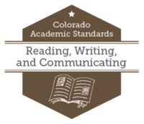
What to look for in the 2018 Reading, Writing, and Communicating Revision
A Reduction in the Prepared Graduate Statements
The 2010 reading, writing, and communicating (RWC) standards laid out 22 separate statements Colorado schools would be responsible for helping graduates master. Across those 22, some were redundant, some included distinctions without difference, and all many worked against a logical flow and ease of use for the standards across pre-K to 12th grade.

Guided by public feedback, redundancies and misalignment cited in a national and international benchmarking report, and a drive to make the RWC standards more user friendly, the 2018 review and revision committee reduced those 22 statements to ten by collapsing related statements and eliminating redundancies. This resulted in a more accessible document with a clear progression of evidence outcomes as they build across each statement and each grade level expectation.

These new Prepared Graduate Statements (PGE) create a clear progression of expected learning while maintaining neutrality on curricular content and allowing for open creativity in designing artifacts of students’ progress toward mastery. The revised PGEs are divided into Oral Expression & Listening, Reading for All Purposes, Writing and Composition, and Research Inquiry and Design.

Prepared Graduates:
- Collaborate effectively as group members or leaders who listen actively and respectfully; pose thoughtful questions, acknowledge the ideas of others; and contribute ideas to further the group’s attainment of an objective.
- Deliver effective oral presentations for varied audiences and varied purposes.
- Read a wide range of literary texts to build knowledge and to better understand the human experience.
- Read a wide range of informational texts to build knowledge and to better understand the human experience.
- Understand how language functions in different contexts, command a variety of word-learning strategies to assist comprehension, and make effective choices for meaning or style when writing and speaking.
- Craft arguments using techniques specific to the genre.
- Craft informational/explanatory texts using techniques specific to the genre.
- Craft narratives using techniques specific to the genre.
- Demonstrate mastery of their own writing process with clear, coherent, and error-free polished products.
- Gather information from a variety of sources; analyze and evaluate its quality and relevance; and use it ethically to answer complex questions.

Refining the Right Side of the Document
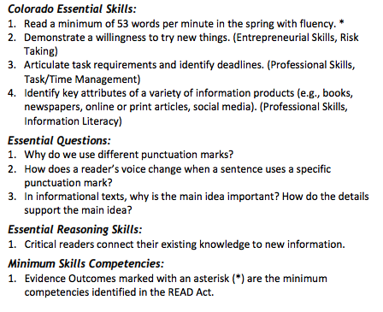
While the 2010 RWC standards included “Inquiry Questions,” “Relevance and Application,” and “Nature of Reading, Writing, and Communicating” under the heading of “21st Century Skills and Readiness Competencies” for each grade-level expectation, the 2018 RWC standards refined this portion of the document to include “Colorado Essential Skills” and “Essential Questions” to help ignite student curiosity and provide possible starting points for curricular design and selection. Additionally, “Essential Reasoning Skills” are identified as components of each grade-level expectation rather than existing as a separate, unintegrated standard.

Greater Specificity Throughout
Responding to requests from public comment for greater clarity, the RWC added evidence outcomes for spelling in order to provide for a clearer progression of expected skill proficiency with an eye toward developmental appropriateness.

To assist schools and districts in curricular planning and development, “Oral Expression and Listening” and “Reading for All Purposes” evidence outcomes that overlap with minimum skill competencies identified in the Colorado READ Act are marked with an asterisk (*) in grades K-3.
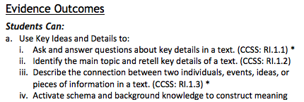
In response to a call for greater flexibility and local control, all mentions of specific texts, genres, or potential curricular content are preceded by “for example” so as to avoid the appearance of dictating any content to districts and schools.

While the review and revision committee worked to refine and clarify evidence outcomes throughout the revised standards, it also recognized the benefit of highlighting where Colorado Academic Standards are aligned to other nationally-recognized standards. To aid districts considering adopting curricular materials sold at the national level and looking to verify standards alignment, the committee included parentheticals such as “(CCSS: SL.K.1)” to assist districts and schools in crosswalking material alignment.

Banding Grade-Level Expectations in High School
Partially in response to misalignment identified by the national and international benchmarking report, and partially in an attempt to recognize limited resources in some of Colorado’s more rural districts and schools, the RWC committee recommended the banding of standards for grades 9-10 and grades 11-12. This move is an attempt to provide for greater local flexibility and control of curricular resources.

