  - What to Look for in the 2020 Physical Education Standards

A Reorganization to Bring Greater Focus on Vertical Alignment, Clarity of Evidence Outcomes, and Components of a Physically Literate Individual.
In 2009/2010, the Colorado Physical Education Standards were revised. These standards provided the base for this revision process. Guided by public feedback, benchmark reports, and the committee’s expertise, misalignment issues and gaps within and across grade levels were identified. Based on feedback it was also identified that some clarification of the standards was needed.

From Prepared Graduate Competencies to Prepared Graduate Statements in Physical Education
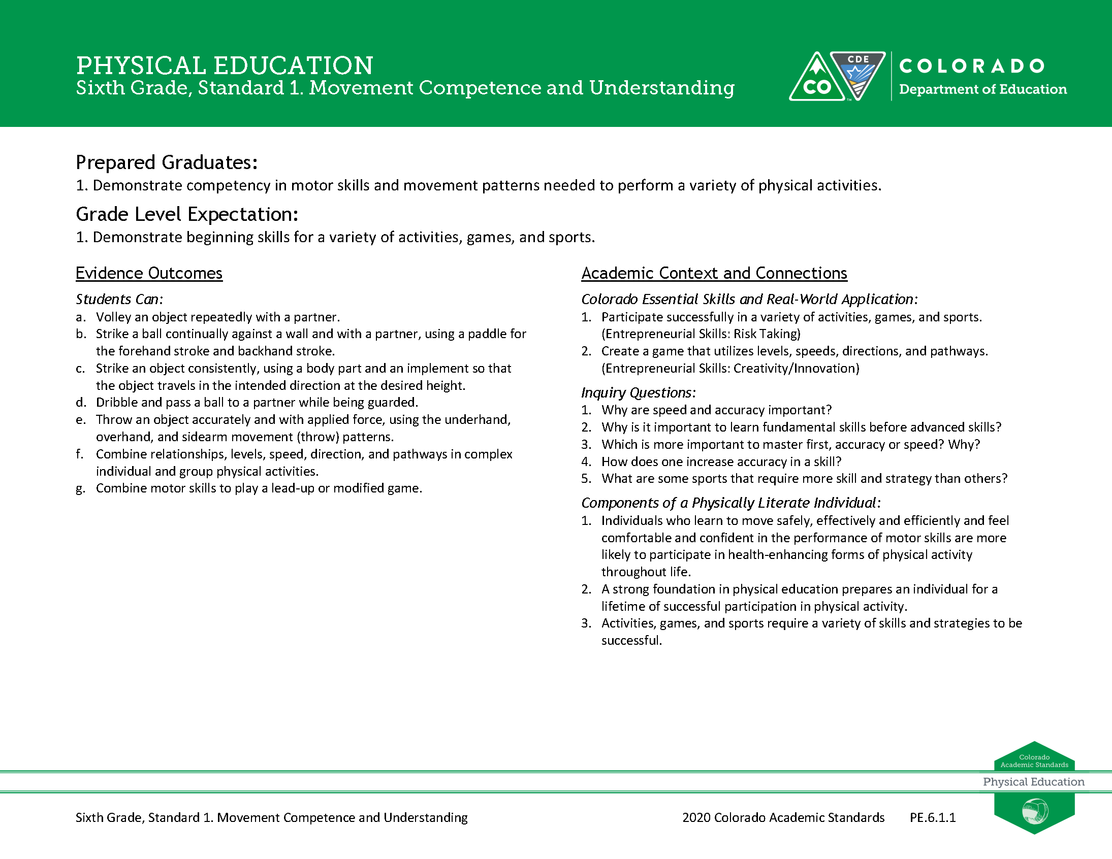
The 2009/2010 Colorado Academic Standards introduced six Prepared Graduate Competencies (PGC) in physical education. These six PGC’s highlighted the preschool through twelfth-grade concepts and skills that all students should master to ensure students are benefiting from skills and knowledge gained through physical education, which enable the participation in a lifetime of physical activity enjoyment and are successful in postsecondary and workforce settings. In the 2018 revision, the term Prepared Graduate Competencies was changed to Prepared Graduate Statements. Four PGC’s related to movement compentence and understanding, physical and personal wellness and prevention and risk management were revised. These changes provided clarity and universal guidence for students to be successful in physical, cognitive, and emotional/social behaviors in a variety of physical activity settings.
2018 Physical Education Standard
In addition, the committee aligned all Prepared Graduate Statements and Grade Level Expectations to span across grade levels preschool through twelfth-grade. This insures that students gain consistency of instruction that focus on essential physical education skills and fundamentals from one grade to the next. Any changes made were to add specificity and clarity, not to fundamentally change what students are expected to learn. Social Emotional Wellness was expanded and aligned across all grade levels.

Adjustments to Right Side of the Document
The 2009/2010 physical education standards had a section titled “21st Century Skills” which house inquiry questions, relevance and application statements, and nature of physical education elements. The 2020 physical education standards have re-titled this section to be, “Academic Content and Conenctions.”
2018 Physical Education Standard
The first component of this section is the “Colorado Essential Skills and Real World Application.” This area highlights the skills and practices that students will be using while mastering the concepts and skills within the grade level expectations and evidence outcomes.
The review and revision committee kept the Inquiry Questions subsection from 2009/2010. The committee designed each question and statement to prompt deeper thinking about the physical education content described by the grade level expectations and evidence outcomes.
2018 Physical Education Standard
Another component of this section is the addition of “Components of a Physically Literate Individual” section replacing the 2009/2010 subsection “Nature of Physical Education”. This section identifies skills, behaviors and opportunities that align with the National Physical Education Standards. Students are able to apply knowledge, demonstrate competency and confidence in all learning domains across physical education in a wide variety of physical activities in various environments. These components of a physically literate individual were identified based on the grade level expectations and evidence outcomes.

Preschool and Early Elementary
The review and revision committee’s preschool revisions are a significant change compared to the 2009/2010 standards, but a minor adjustment when compared with CDE’s 2013 Early Learning Development Guidelines and the latest revision of the Head Start Early Learning Outcomes Framework. A major focus in Preschool and Early Elementary focused on the development of social emotional skills.

Level 1/Level 2 High School Standards
In the 2018 revisions, the evidence outcomes were revised and identified as Level 1 or Level 2 in the high school physical education standards. The committee’s decision to label evidence outcomes as a Level 1 or Level 2 was to guide teacher’s instruction from easiest to hardest. The labeling can also be used to guide the development of multiple courses and a scope and sequence based on higher and lower level skills.
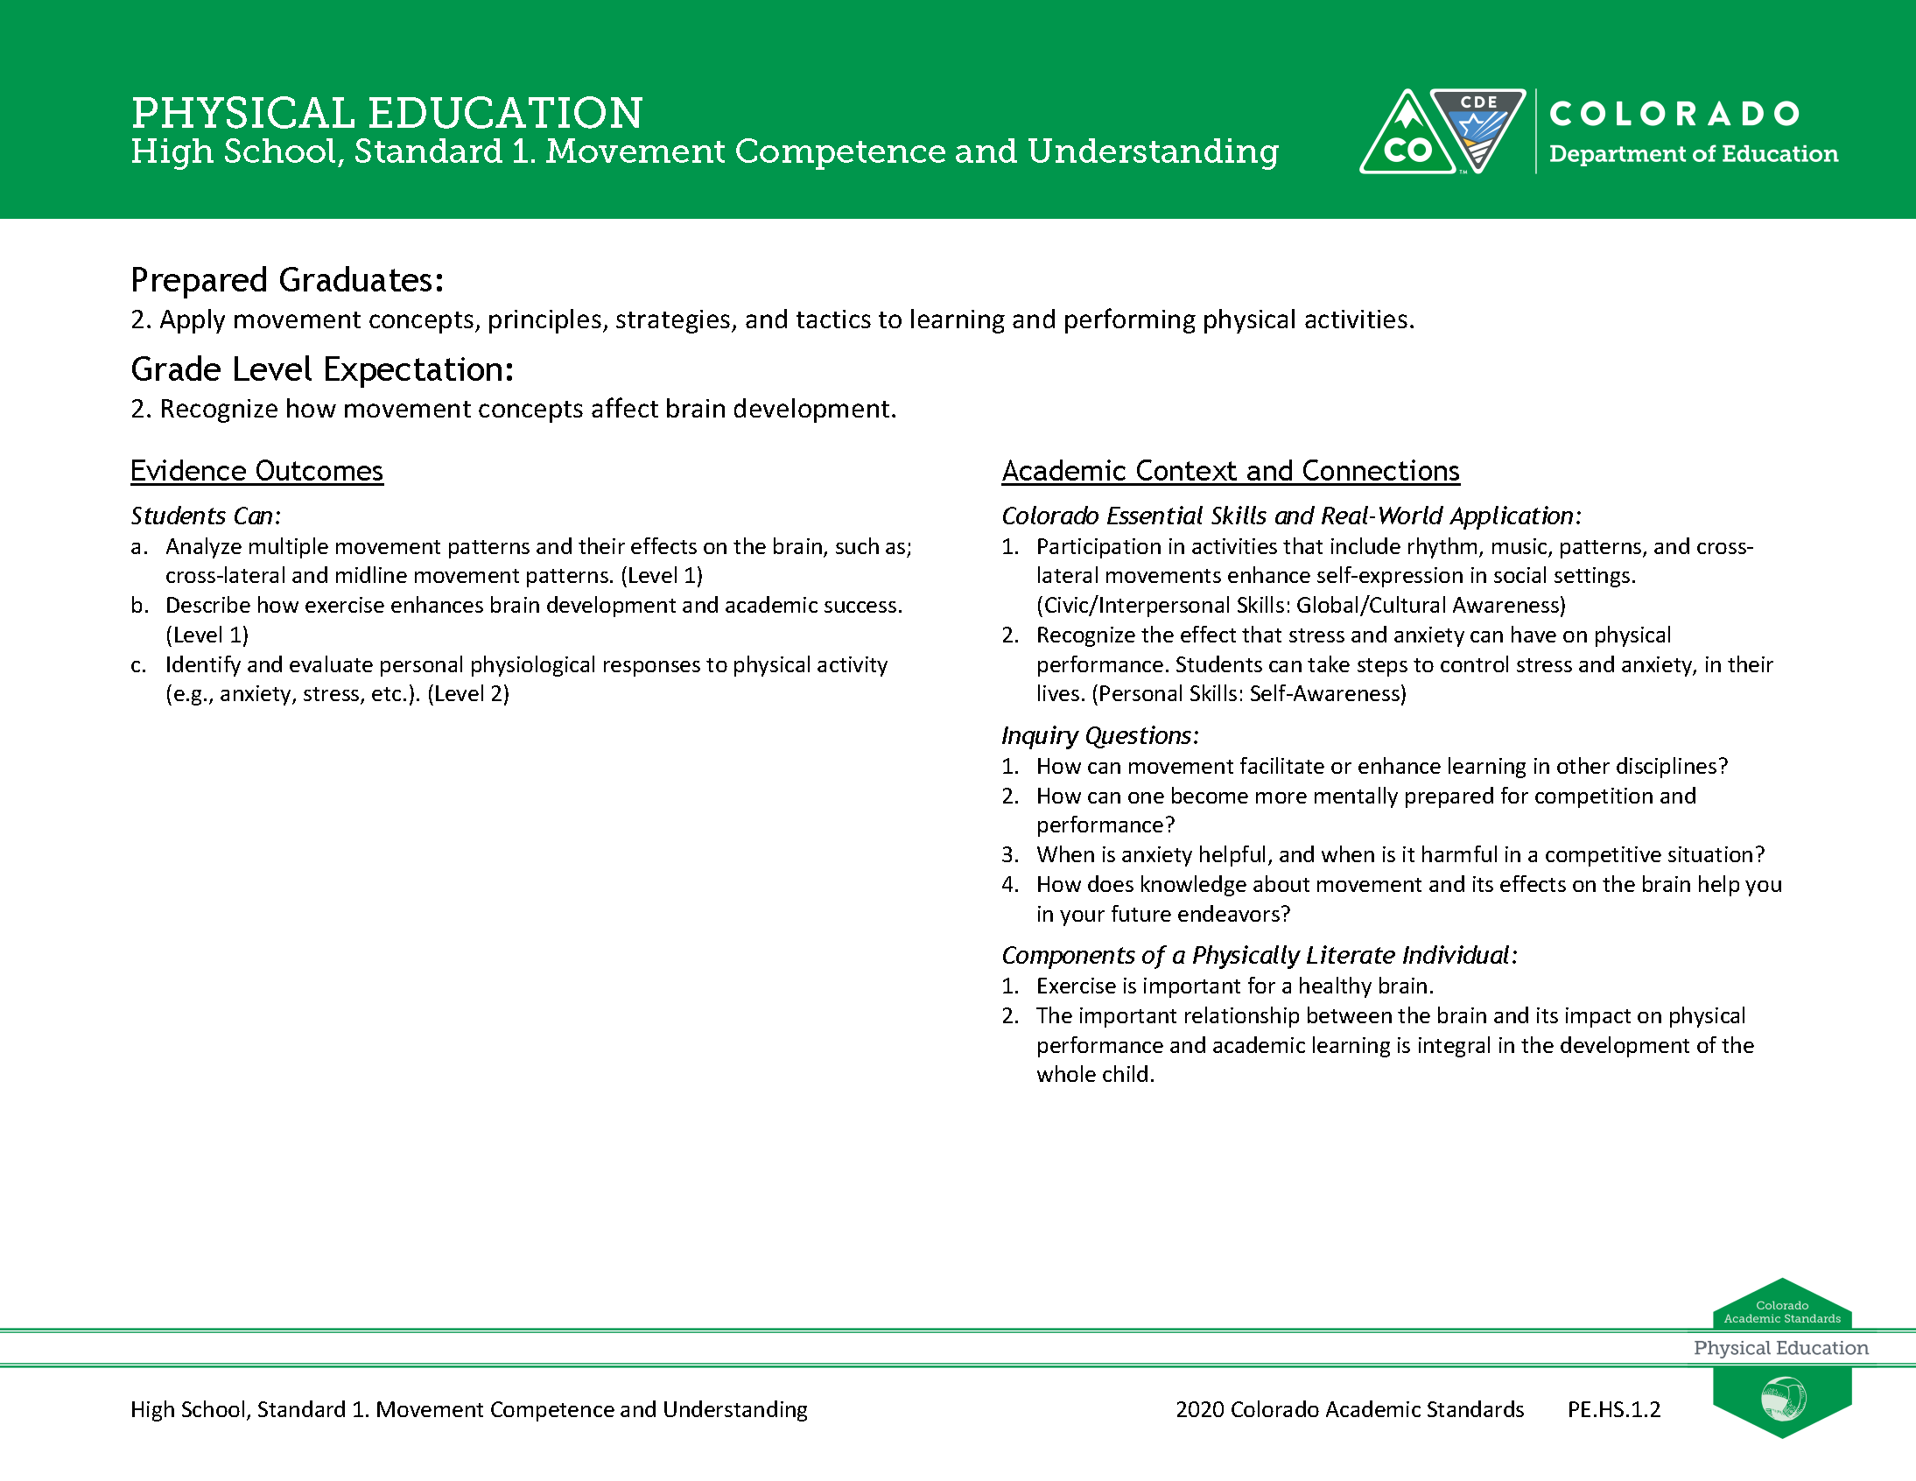
2018 Physical Education Standard

