  - What to Look for in the 2018 Music Revision

Improved Clarity and Alignment for the Discipline of Music
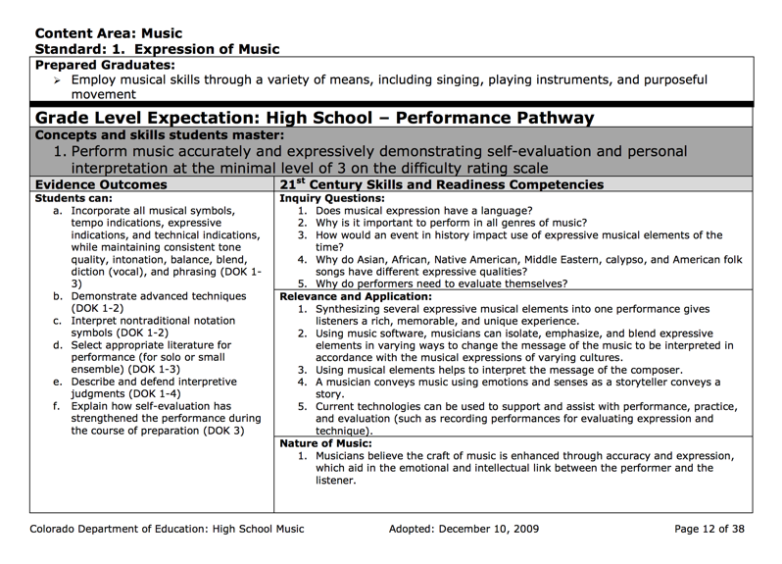
2010 Music Standards
The 2010 Music Standards organized music content into four main areas: Expression, Creation, Theory, and Aesthetic Valuation. Within these Standards, conceptual learned was organized as evidence outcomes (EOs) under grade level expectations (GLEs).
Guided by public feedback, lack of rigor, breadth, and depth issues cited in a benchmarking report, and their own experience with the standards, the 2018 Review and Revision Committee reorganized the standards into GLEs, more tightly focused on a dance concept with fewer EOs.
The Committee reviewed the standards and improved alignment from PK-HS by combining some EOs and clarifying language. Any changes made were to add specificity and clarity, not to fundamentally change what students are expected to learn.
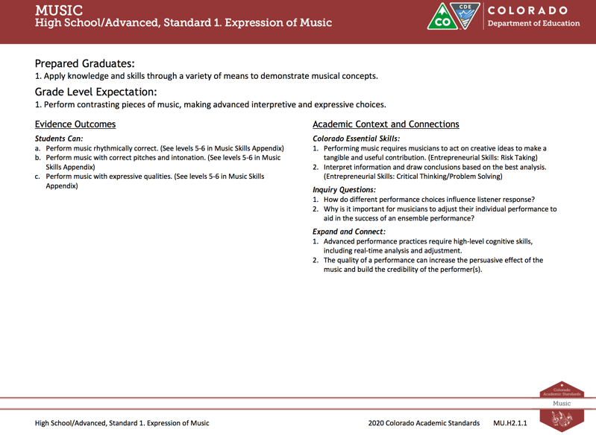

2018 Music Standards

Updated Definitions for the Four Colorado Academic Standards in Music
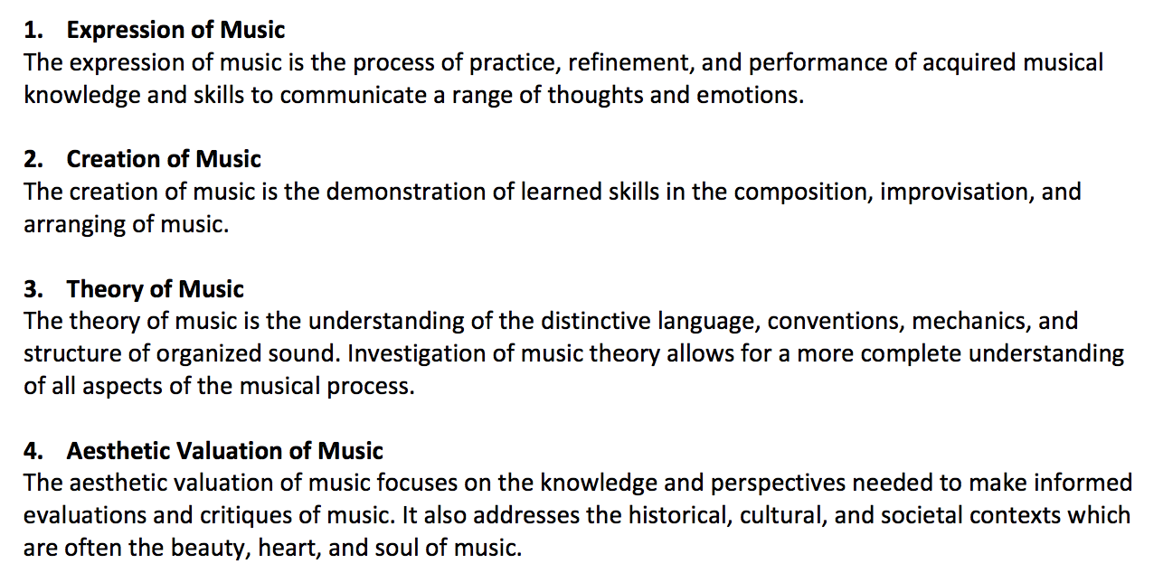
The Review and Revision Committee also streamlined the definitions of the updated Colorado Academic standards.
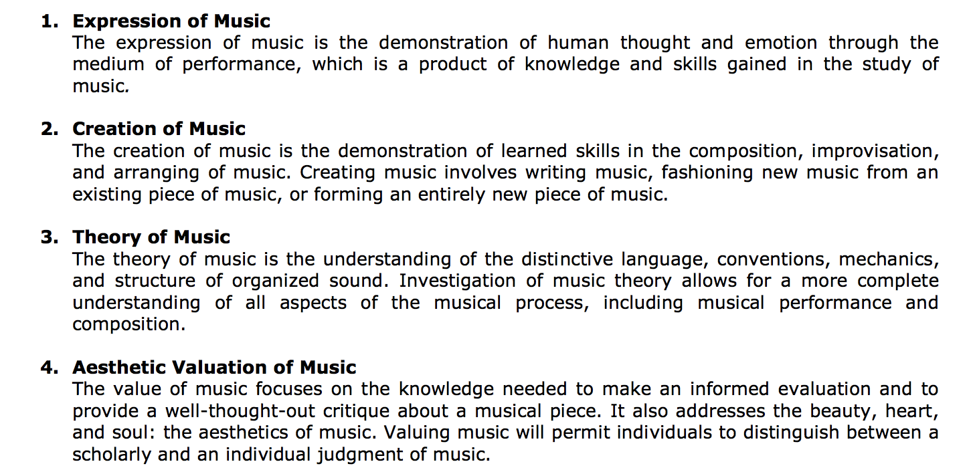
2018 Music Standards Definitions

From Prepared Graduate Statements to Prepared Graduate Competencies in Music
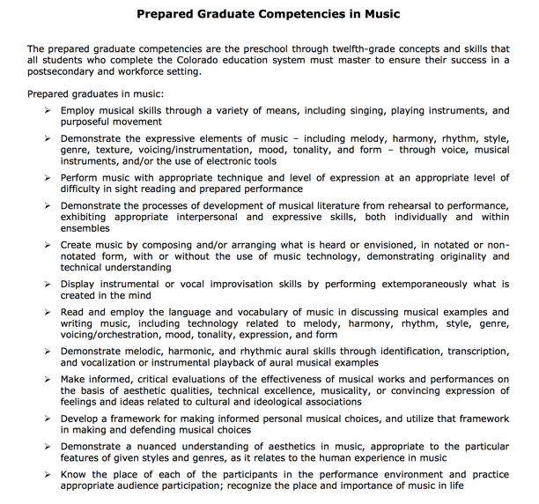
The 2010 Colorado Academic Standards introduced twelve Prepared Graduate Competencies (PGC) in Music. These twelve PGC’s highlighted the preschool through twelfth-grade concepts and skills that all students who complete course work in music must master to ensure success in a postsecondary and workforce setting.
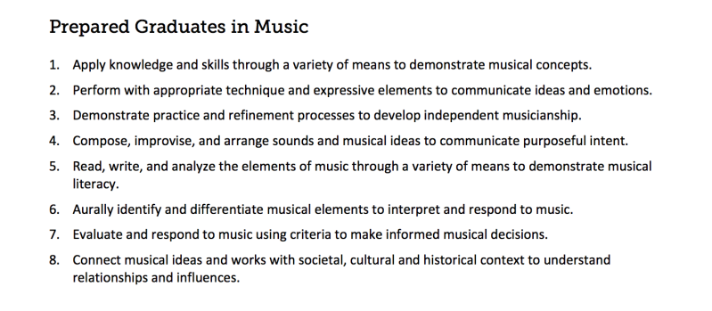
Since 2010, music educators across Colorado have embraced the PGC’s and elevated their status to support the learning of music content and techniques. The 2018 dance standards review and revision committee received feedback from a bench-mark report as well as the public to decide that the PGC’s should be consolidated in the revised standards.
2010 Music Prepared Graduate Competencies

In the 2018 revision, the term Prepared Graduate Competencies was changed to Prepared Graduate Statements and consolidated the twelve concepts and skills to eight statements.

2018 Music Prepared Graduate Statements
Academic Context and Connections
In addition, the committee replaced the 21st Century Skills and Readiness Competencies subheading with Colorado Essential Skills. These skills are content specific and connect directly to the Essential Skills Guidance Resource document. The categories of Relevance and Application and Nature of Music were deleted all together, leaving the categories of Inquiry Questions and one new category, Expand and Connect.
2010 Music Standards

Inquiry Questions and Expand and Connect
The review and revision committee kept the Inquiry Questions subheading from 2010 standards and made few updates and additions. The committee designed each question and statement to prompt deeper thinking about the music content described by the grade level expectations and evidence outcomes. The new category, Expand and Connect, is examples of how the Music Grade Level Expectations relate to other content areas, other music standards, and real-world applications.
2018 Music Standards

Preschool
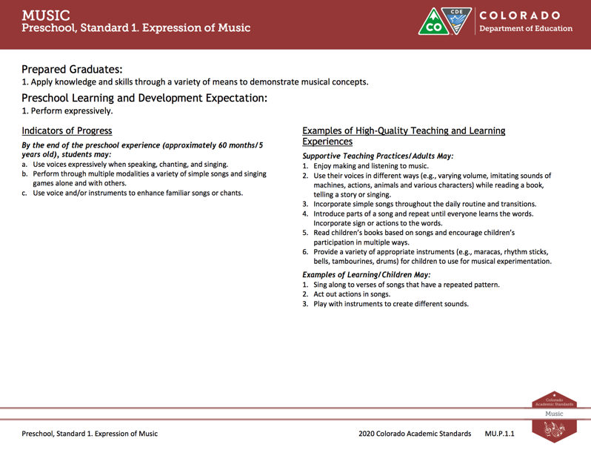
The Review and Revision Committee’s preschool revisions are a significant change compared to the 2009 standards, but a minor adjustment when compared with CDE’s 2013 Early Learning Development Guidelines. As in the other content areas of in the 2020 standards, instead of Grade Level Expectations in preschool there are Preschool Learning and Development Expectations. Instead of Evidence Outcomes there are Indicators of Progress. Instead of Academic Context and Connections there are Examples of High Quality Teaching and Learning Experiences.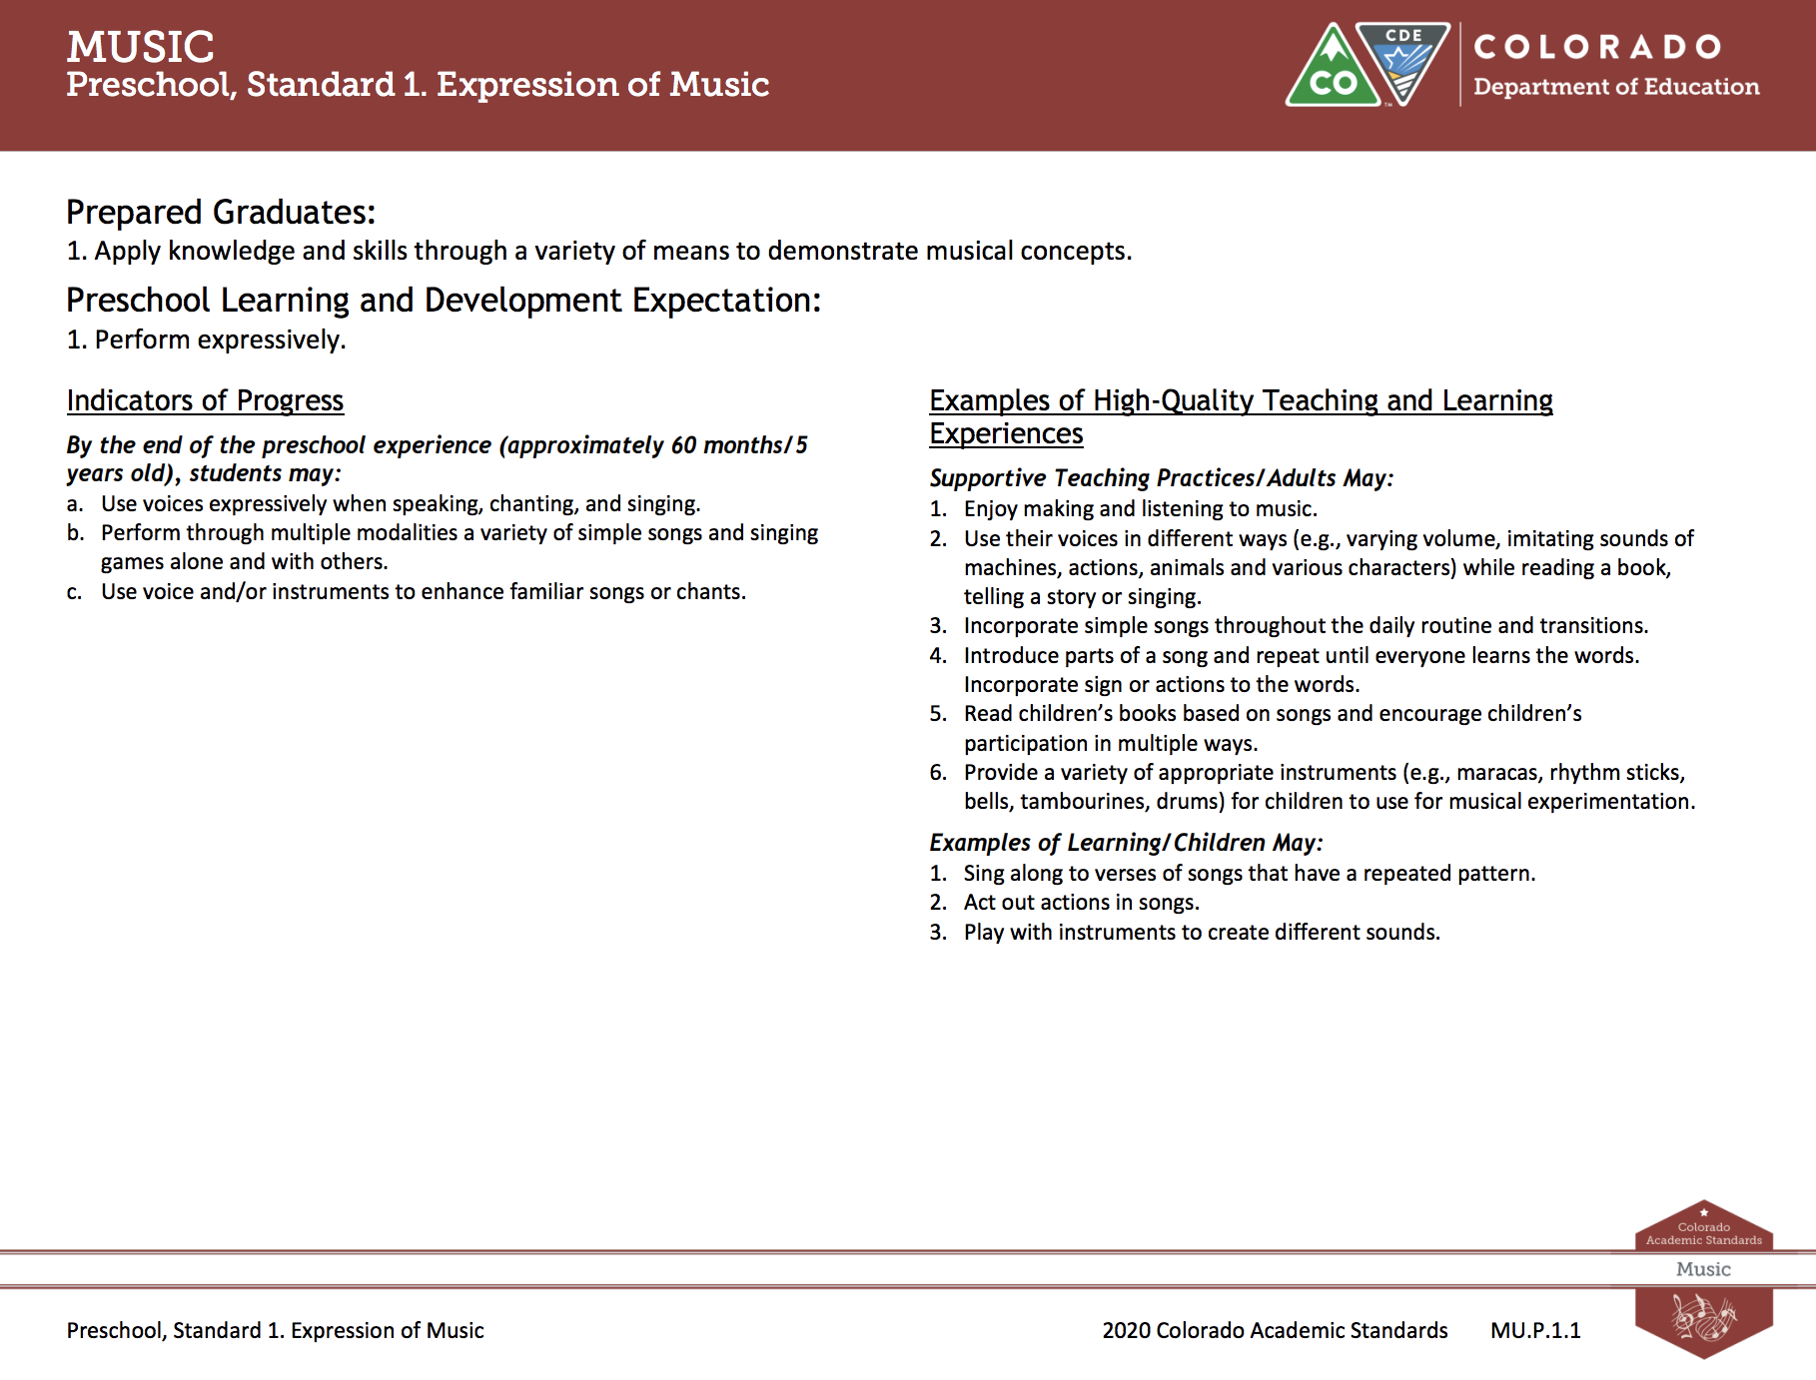

2018 Music Standards

Skill Acquisition Levels in Secondary Music

As part of the revision of the standards for grades 6 through high school, the review and revision added Skill Acquisition Levels. These levels give a secondary teacher the opportunity to differentiate instruction for students based on the student’s experience level with learning and performing music. The skill acquisition levels are:
- Sixth Grade/Novice
- Seventh Grade/Intermediate
- Eighth Grade/Proficient

- High School/Accomplished
- High School/Advanced

