  - What to Look for in the 2018 Drama and Theatre Arts Revision

A Reorganization to Bring Greater Focus and Stronger Connections to Process in Drama and Theatre Arts (DTA)

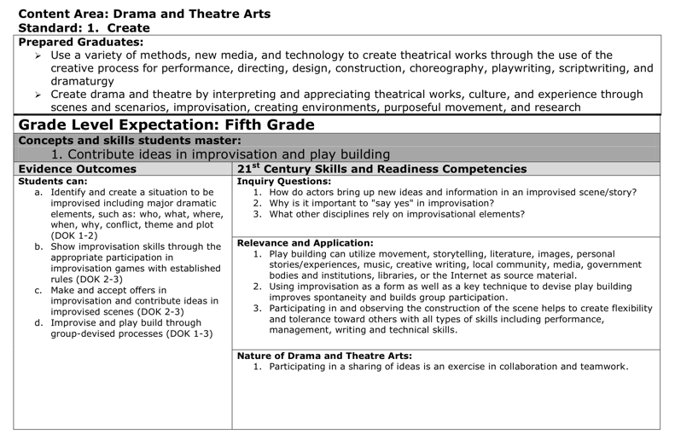
The 2010 Drama and Theatre Arts (DTA) standards often brought many evidence outcomes (EOs) together under a single grade level expectation (GLE).
Guided by public feedback, misalignment issues cited in a benchmarking report, and their own experiences with the standards, the 2018 review and revision committee reorganized the standards into Prepared Graduate Statements (PGS’s) and GLEs, more tightly focused on theatrical concepts and processes with fewer EOs.
2010 DTA Standards
2018 DTA Standards
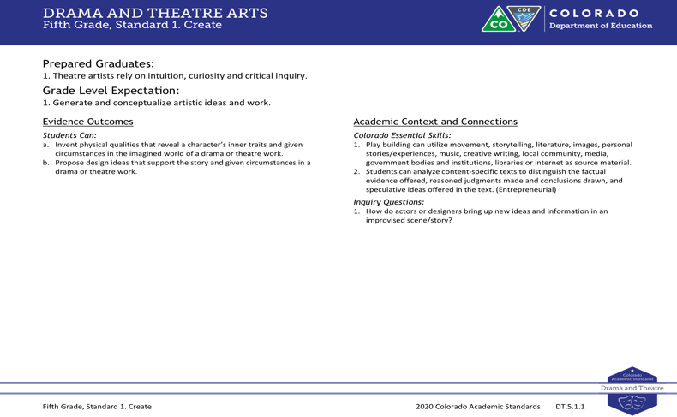

The committee combined and refined the language of individual EOs. Any changes made were to add specificity and clarity, not to fundamentally change what students are expected to learn.

From Prepared Graduate Competencies to Prepared Graduate Statements in Drama and Theatre Arts
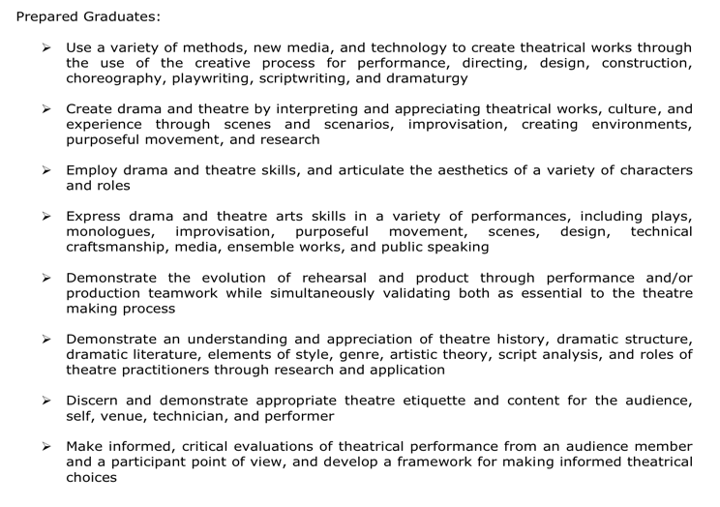
The 2010 Colorado Academic Standards introduced eight Prepared Graduate Competencies (PGC) in DTA. These eight PGC’s highlighted the preschool through twelfth-grade concepts and skills that all students who complete course work in DTA must master to ensure success in a postsecondary and workforce setting.
Since 2010, drama educators across Colorado have embraced the PGC’s and elevated their status to support the learning of theatrical content and creative processes. The 2018 DTA standards review and revision committee received feedback from a benchmark report as well as the public to decide that the PGC’s should be more focused and in-depth in the revised standards.
2010 DTA Prepared Graduates

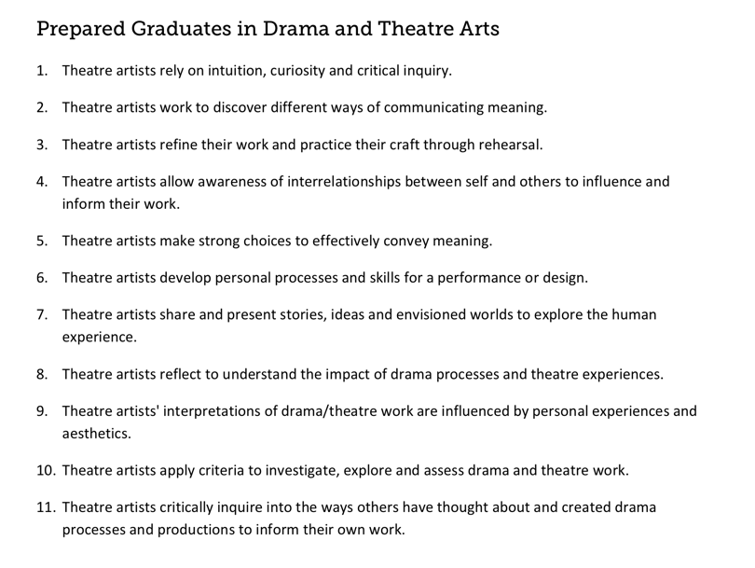
In the 2018 revision, the term Prepared Graduate Competencies was changed to Prepared Graduate Statements and the eight DTA concepts and skills were expanded to eleven.

2018 DTA Prepared Graduates

In addition, the committee aligned all Prepared Graduate Statements and Grade Level Expectations to span across grade levels preschool through twelfth-grade. This insures that students gain consistency of instruction, artistic process, and creative skills from one grade to the next.

Preschool - 12th Grade
Standard |  | Grade Level Expectation | Prepared Graduate Statement
1. Create |  | Generate and conceptualize artistic ideas and work | Theatre artists rely on intuition, curiosity, and critical inquiry
 |  | Organize and develop artistic ideas and work | Theatre artists work to discover different ways of communicating meaning
 |  | Refine and complete artistic work | Theatre artists refine their work and practice their craft through rehearsal.
 |  | Synthesize and relate knowledge and personal experience to make art | Theatre artists allow awareness of interrelationships between self and others to influence and inform their work.
2. Perform |  | Select, analyze, and interpret artistic work for presentation | Theatre artists make strong choices to effectively convey meaning.
 |  | Develop and refine artistic techniques, choices, and work for presentation | Theatre artists develop personal processes and skills for a performance or design.
 |  | Convey meaning through the presentation of artistic work | Theatre artists share and present stories, ideas, and envisioned worlds to explore the human experience.
3. Critically Respond |  | Perceive and analyze artistic work | Theatre artists reflect to understand the impact of drama processes and theatre experiences
 |  | Interpret intent and meaning in artistic work | Theatre artists' interpretations of drama/theatre work are influenced by personal experiences and aesthetics
 |  | Apply criteria to evaluate artistic work | Theatre artists apply criteria to investigate, explore, and assess drama and theatre work
 |  | Relate artistic ideas and works with societal, cultural, and historical context to deepen understanding | Theatre artists critically inquire into the ways others have thought about and created drama processes and productions to inform their own work

Adjustments to Right Side of the Document

Also, the committee replaced the 21st Century Skills and Readiness Competencies subheading with Colorado Essential Skills. These skills are content specific and connect directly to the Essential Skills Guidance Resource document. The categories of Relevance and Application and Nature of Drama and Theatre Arts were deleted all together, leaving the category of Inquiry Questions.

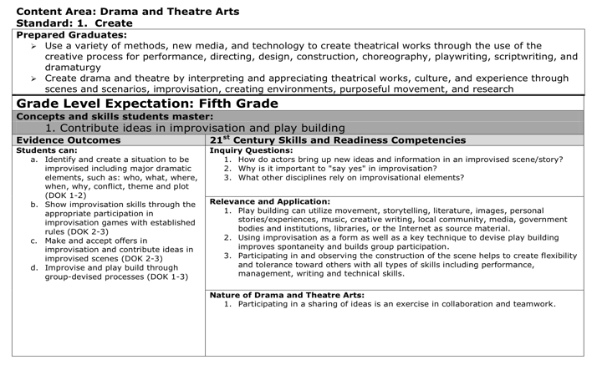
2010 DTA Standards
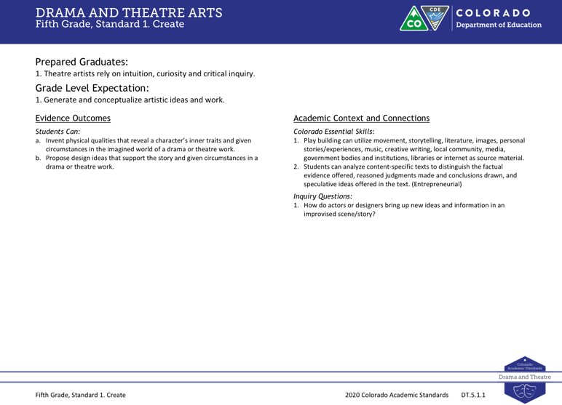
2018 DTA Standards

Inquiry Questions
The review and revision committee kept the Inquiry Questions subheading from 2010 and made some additions. The committee designed each question and statement to prompt deeper thinking about the drama and theatre arts content described by the grade level expectations and evidence outcomes.

