  - What to Look for in the 2018 Dance Revision

A Consolidation to Bring Greater Focus and a Stronger Connection to Ideas in the Discipline of Dance

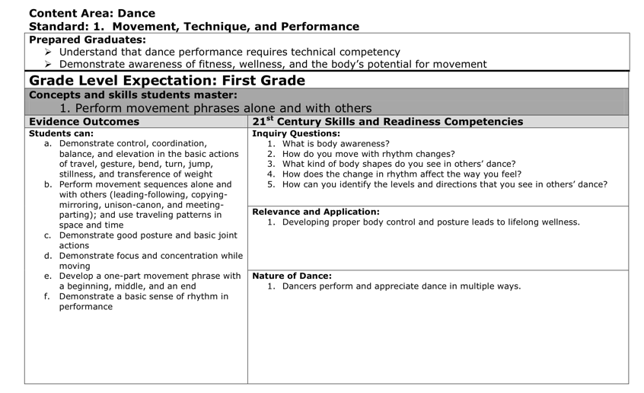
The 2010 dance standards often brought many evidence outcomes (EOs) together under a single grade level expectation (GLE).
Guided by public feedback, misalignment issues cited in a benchmarking report, and their own experience with the standards, the 2018 review and revision committee reorganized the standards into GLEs, more tightly focused on a dance concept with fewer EOs.
2010 Dance Standards

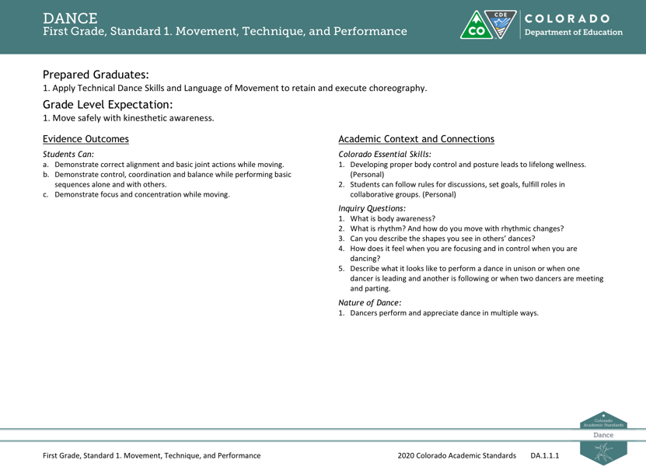
2018 Dance Standards

The committee combined some EOs, specifically in grades K-5. In all but a small number of cases, the committee retained the language of individual EOs. Any changes made were to add specificity and clarity, not to fundamentally change what students are expected to learn.

Prepared Graduate Competencies to Prepared Graduate Statements in Dance
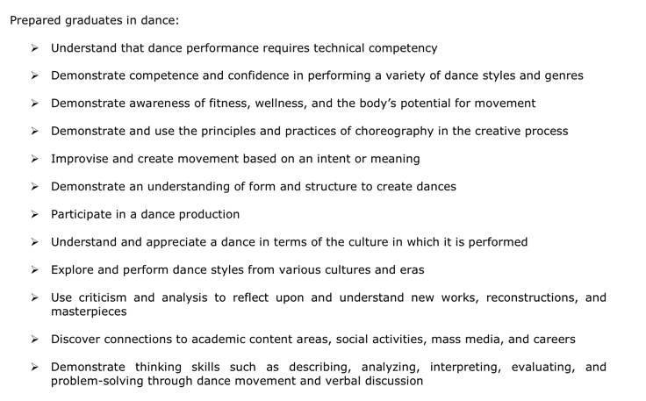
The 2010 Colorado Academic Standards introduced twelve Prepared Graduate Competencies (PGC) in Dance. These twelve PGC’s highlighted the preschool through twelfth-grade concepts and skills that all students who complete course work in dance must master to ensure success in a postsecondary and workforce setting.
Since 2010, dance educators across Colorado have embraced the PGC’s and elevated their status to support the learning of dance content, techniques and choreographic practices. The 2018 dance standards review and revision committee received feedback from a bench-mark report as well as the public to decide that the PGC’s should be more consolidated in the revised standards.

2010 Dance Prepared Graduates
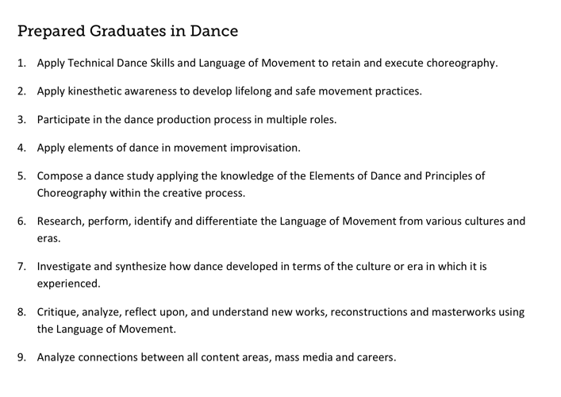
2018 Dance Prepared Graduates

In the 2018 revision, the term Prepared Graduate Competencies was changed to Prepared Graduate statements and consolidated the twelve concepts and skills to nine statements.

In addition, the committee replaced the 21st Century Skills and Readiness Competencies subheading with Colorado Essential Skills. These skills are content specific and connect directly to the Essential Skills Guidance Resource document. The category of Relevance and Application was deleted all together, leaving the categories of Inquiry Questions and Nature of Dance.
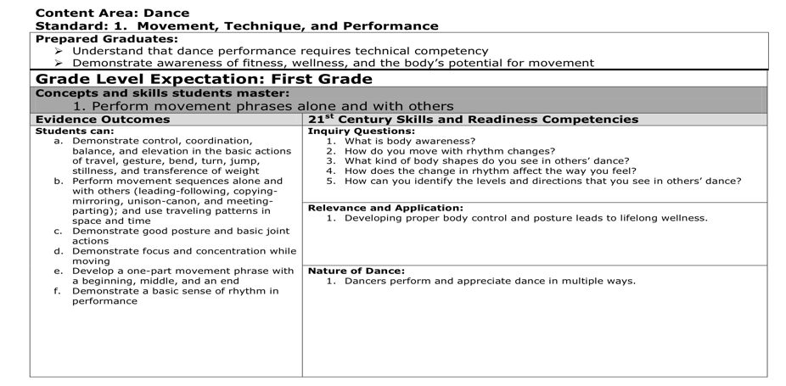
2010 Dance Standards
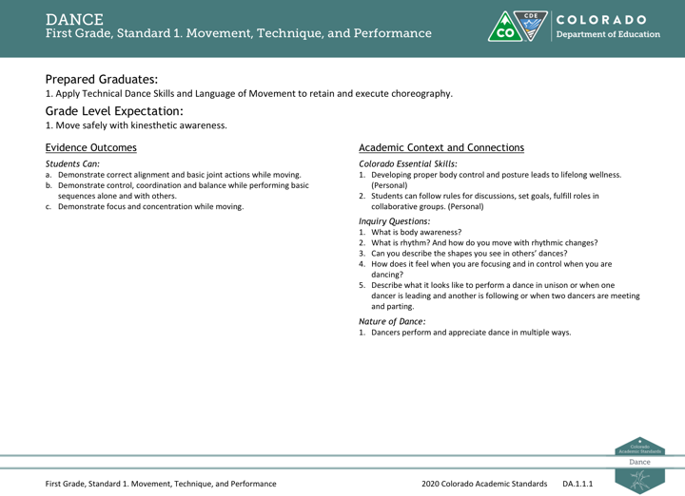
2018 Dance Standards

Inquiry Questions and Nature of Dance
The review and revision committee kept the Inquiry Questions and Nature of Dance subheadings from 2010 and made few additions. The committee designed each question and statement to prompt deeper thinking about the dance content described by the grade level expectations and evidence outcomes.

