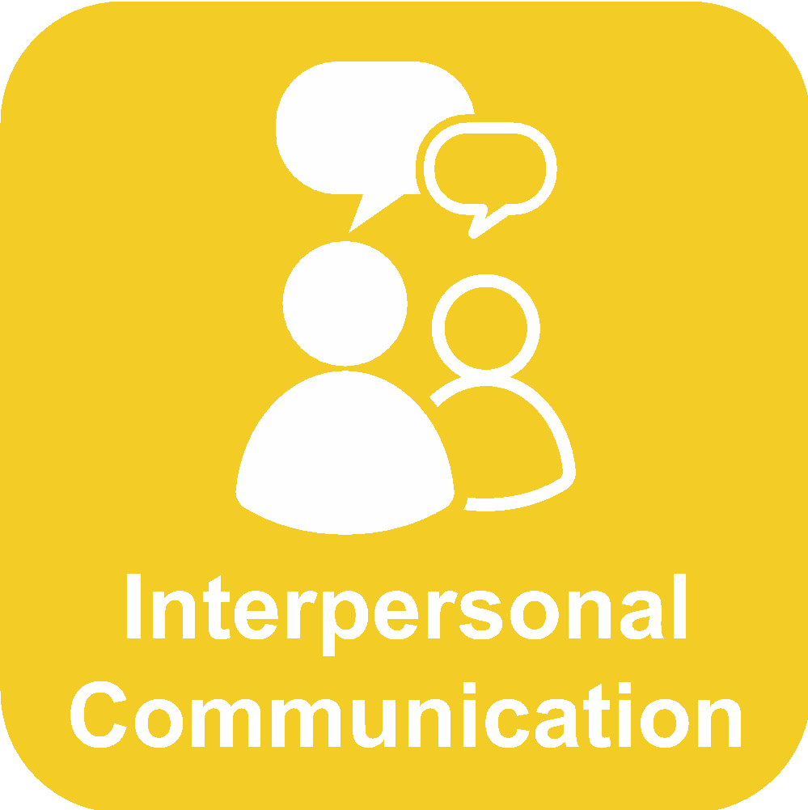**Grades 6-8**

**Interpersonal Collaboration Skills**

**Background Information:**

Collaboration skills is one of the recognized 21st century skill areas. It is important for students to know how to work in group situations to accomplish common goals. These skills are introduced and reinforced throughout their PK-12 experience. By the time they reach high school, they should have the skills necessary to successfully contribute to a group situation.

Collaboration skills at the 3-5 grade level involves moving beyond partner work into more independent small group situations. Individuals in the groups are expected to take on different roles and responsibilities. Group norms need to be established with teacher guidance and respected while completing the task in the small groups.

**The Model**

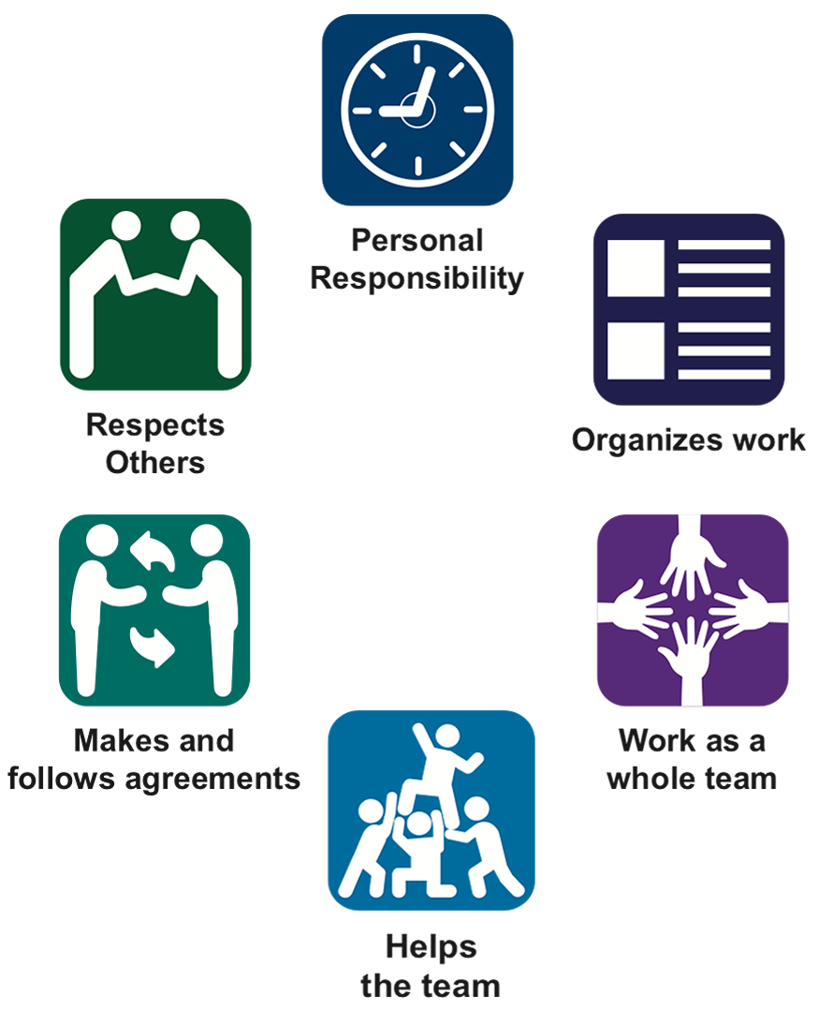

**The Techniques**

|  |  |  |
| --- | --- | --- |
| **Technique** | **Teaching Progression** | **Teaching Considerations/Examples** |
| **Makes and follows agreements** | Students in the group need to be able to develop agreements that everyone can use during the process. These might include:   * Makes agreements about how the team works * Rules for discussions * Rules for making group decisions or develop consensus * Rules for how to resolve conflicts * Appropriately takes action when agreements are broken * Attempts to resolve issues without adult help | Agreements need to be general and written in the positive. Practice needs to happen in being able to stand up to team members that are breaking the agreements. They also need to understand that before they go to a teacher, they need to make sure they have tried to solve the problem first. |
| **Organizes work** | When a group is collaborating, they need to be organized and have accountability for their work. This area includes:   * Assign roles for with a task list for each member * Set a schedule in order to meet deadlines * Work is divided fairly and evenly between members * Materials are organized * Members use their time wisely | The students need set and concrete roles, check in dates, and places to keep materials. The group will have more success if the teacher controls the “chunking” of the activity in order to create the whole product. |
| **Personal Responsibility** | * Is prepared and ready to work * Uses technology to complete work * Completes tasks on time and without being reminded * Uses feedback from others to improve work | One of the areas that is the most difficult for middle school is the ability to give feedback so that it is not perceived as being mean or a put down. A suggestion would be to teach the students to give a positive first, then give the idea for improvement. Time also needs to be spent on how to give the feedback and accept criticism. |
| **Work as a whole team** | As a team, members need to use the talents of each member. If any ideas or products are developed individually, they are brought back to the group for feedback.   * Uses special talents of each member * Creates products with the help of all members * Work done separately is brought to the group for critique and revision | Even though students will gravitate towards roles they feel comfortable with, it is okay for them to try different jobs that they might not feel they can accomplish. Teachers can also make sure projects for collaboration have a menu of possible products. |
| **Respects others** | Respecting others allows the group to focus on the final product.   * Treats teammates politely * Listens to other points of view * Respects others perspectives * Disagrees appropriately * Compromises | Time needs to be spent teaching students polite ways to disagree. They also need to be made aware of the fact that they are working together for a common goal--not becoming best friends. |
| **Helps the team** | Successful collaboration also involves help from all members.   * Following rules and asking questions * Providing feedback to others in the group * Helping others who need it * Solves problems and manages conflicts * Contributes effectively to discussions * Helps others that need it | This is important for the teacher to monitor this throughout the collaboration activity. One other issue is that if a student is having difficulty doing their part, the student needs to make sure they are helping, rather than taking over and doing the whole project. |

**Sample Student Handout**

Handouts can be found at www.rmc.org/healthskills

|  |  |  |
| --- | --- | --- |
| Macintosh HD:Users:davidturner:Documents:Health Skills Models:Collaboration:Formatted Handouts:6-8  Collaboration Skills 8-22-16 .jpg |  | **Teaching Tips:**   * **Key vocabulary:** personal responsibility, assertive, active listening, cooperation, compromise, consensus, collaboration, agreements * **Teaching Strategy:**   + When first using collaborative groups, it is more important to focus on the skills of collaboration rather than the final product.   + Choose a skill to work on and focus on that skill with a very simple final product.   + For example, the teacher might want to work on appropriate behavior when working in a group. The teacher will instruct students on the skills of sharing, taking turns, and not using put downs. The product might be to create a poster with each group contributing one picture. The teacher will spend the majority of the time assessing their ability to behave appropriately, while the final product is secondary.   + As teachers observe students working in groups, the next lessons will be based on the skills the students lack during the observations.   + As students become more proficient at the skills, the more the emphasis can shift to the final product.   + As a final processing of every collaborative group activity, have students take turns and compliment someone in the group on how they worked and what they did to help the group be successful.   + Partner activities are advised. It is also important to start off with simple tasks that don’t require too much time so students achieve some success with their partners.   + When grouping students, use no more than 4 in group.   + At the lower grades it might be helpful to have parent/older student leaders that will help the group. * **Role-play:** communication skills, asking for help, and I messages. * **Homework:** Parents can help students practice working together with family members or peers. * **Discussion questions:**   + Why is it important to learn how to work in groups?   + What makes a good work partner?   + How can we make decisions as a group?   + What do you do if you don’t get along with the people in your group?   + What if my partner makes me mad? What do I do? * **Assessment ideas:** observation, self-assessment, group member evaluations, process reflection, analyze a scenario. |
| **Integration:**  Collaboration Skills can be used in any content area during group projects, assignments, and during classroom activities. |
|  |  |  |
| **What Does Mastery of Interpersonal Communication Look Like:**  Mastery of collaboration in Grades 6-8 is observed when students can successfully collaborate in a way where they actively listen, communicate assertively, compromise, participate in a group decision, and demonstrate personal responsibility during the collaborative activity. |  | **Teaching/Student Resources**  **The Colorado Education Initiative** <http://www.coloradoedinitiative.org/resources/chpe/>  **RMC Health**  <http://www.rmc.org/>  **Colorado Department of Education**  <http://www.cde.state.co.us/cohealthpe/statestandards> |

|  |  |
| --- | --- |
| Macintosh HD:Users:davidturner:Documents:Health Skills Models:Collaboration:Icons:Finals:Handout Icons:IC.eps | **Teamwork Rating** |

* **Using the rating scale circle how you feel you contributed to the team.**
* **Underline the level that your overall team contributed.**
* **Provide evidence.**

|  |  |  |  |
| --- | --- | --- | --- |
|  | **Behavior** | **Rating (1 is the best)** | **Evidence** |
| **Macintosh HD:Users:davidturner:Documents:Health Skills Models:Collaboration:Icons:Finals:Handout Icons:PR.eps**  **Takes responsibility for oneself** | Has supplies and is ready to work | 1 2 3 4 5 |  |
| Stays on task in the group | 1 2 3 4 5 |  |
| **Macintosh HD:Users:davidturner:Documents:Health Skills Models:Collaboration:Icons:Finals:Handout Icons:HelpsTeam.eps**  **Helps the team** | Solves problems in the group | 1 2 3 4 5 |  |
| Gives appropriate feedback to group members | 1 2 3 4 5 |  |
| **Macintosh HD:Users:davidturner:Documents:Health Skills Models:Collaboration:Icons:Finals:Handout Icons:Respect.eps Respects others** | Polite and kind to team members | 1 2 3 4 5 |  |
| Disagrees appropriately | 1 2 3 4 5 |  |
| **Macintosh HD:Users:davidturner:Documents:Health Skills Models:Collaboration:Icons:Finals:Handout Icons:Agreements.eps**  **Makes and follows agreements** | Follows rules made by the group | 1 2 3 4 5 |  |
| Takes appropriate action when group rules are broken | 1 2 3 4 5 |  |
| **Macintosh HD:Users:davidturner:Documents:Health Skills Models:Collaboration:Icons:Finals:Handout Icons:Organizes.eps Organizes work** | Meets deadlines | 1 2 3 4 5 |  |
| Keeps materials and notes organized | 1 2 3 4 5 |  |
| **Macintosh HD:Users:davidturner:Documents:Health Skills Models:Collaboration:Icons:Finals:Handout Icons:WorkasTeam.eps**  **Works as a whole team** | Participates effectively in assigned role | 1 2 3 4 5 |  |
| Final product | 1 2 3 4 5 |  |

|  |  |
| --- | --- |
| Macintosh HD:Users:davidturner:Documents:Health Skills Models:Collaboration:Icons:Finals:Handout Icons:IC.eps | **Collaboration Flowchart Organizer** |

|  |  |  |  |  |
| --- | --- | --- | --- | --- |
| Macintosh HD:Users:davidturner:Documents:Health Skills Models:Collaboration:Icons:Finals:Handout Icons:Roles.eps | Macintosh HD:Users:davidturner:Documents:Health Skills Models:Collaboration:Icons:Finals:Handout Icons:Agree.eps | Macintosh HD:Users:davidturner:Documents:Health Skills Models:Collaboration:Icons:Finals:Handout Icons:ID Task.eps | Macintosh HD:Users:davidturner:Documents:Health Skills Models:Collaboration:Icons:Finals:Handout Icons:Responsibilties.eps | Macintosh HD:Users:davidturner:Documents:Health Skills Models:Collaboration:Icons:Finals:Handout Icons:Product.eps |
| **Assign Roles:**  **Recorder**  **Presenter**  **Timer**  **Facilitator**  **Speaker** | **Set and establish agreements for the group.** | **Identify the task or final product.** | **Responsibilities:**  **How to make decisions**  **Team member accountability**  **Asking for help** | **Final Product:**  **Recognize successes**  **Discuss challenges**  **Reflect** |

**Step 1: Assign Roles: Take a look at the roles and decide who is going to responsible in your group.**

|  |  |  |
| --- | --- | --- |
| **Role** | **Definition** | **Person Responsible** |
| Facilitator | This person will lead the group. They do not do all of the work, but they make sure everything runs smoothly by being organized. They can also delegate jobs to other members. |  |
| Recorder | The recorder takes notes and keeps track of everything the group is doing. They are responsible for keeping track of papers and information for the group. |  |
| Time Keeper | The timekeeper makes sure the group stays on task. They will watch the clock and remind the group when it is time to move on to the next task. |  |
| Presenter | This person is in charge of organizing the presentation if it is needed. They make sure the product has an acceptable quality. |  |
| Speaker | The speaker is the one who will be in charge if any of the presentation is done orally. They will be the person that asks for help and helps gather materials. |  |

**Step 2: Set and establish norms/agreements for the group.**

The **facilitator** will lead the group into coming up with 3-5 rules the group will use during the collaborative experience.

|  |  |
| --- | --- |
| **Agreement** | **Why is this agreement needed?** |
| 1. |  |
| 2. |  |
| 3. |  |
| 4. |  |
| 5. |  |

**Step 3: Identify the task or final product:**

The **recorder** will write down a description of the task or final product.

|  |
| --- |
|  |

**Step 4: Group operations**

The **facilitator** will lead a discussion on the following topics. The **recorder** will record the results.

|  |  |
| --- | --- |
| **Group operations** | **Results of the discussion** |
| How will the group make decisions? |  |
| What are the expectations of the team members? | 1.  2.  3. |
| Who, how and when do we ask for help? |  |
| How do we solve problems in the group? |  |

**Step 5: Final product: Successes and reflection**

1. Is the final product meet the requirements and is the quality acceptable? Explain.
2. How did we support or show our appreciation to our other group members?
3. Did everyone contribute equally? Explain.
4. If there were any problems in the group, how were they solved? Explain.
5. What did you learn about collaboration?
6. How can we celebrate our successes?
7. What would you do differently next time?