  - What to Look for in the 2020 Health Education Standards

A Reorganization to Bring Greater Focus on Vertical Alignment, Clarity of Evidence Outcomes, and Identification of Key Health Skills.
In 2009/2010 Colorado developed the first Comprehensive Health Education Standards for Colorado. These standards provided the base for this revision process. Guided by public feedback, benchmark reports, and the committee’s expertise, misalignment issues and gaps within and across grade levels were identified. Based on feedback it was also identified that some clarification of the standards was needed.

From Prepared Graduate Competencies to Prepared Graduate Statements in Health Education
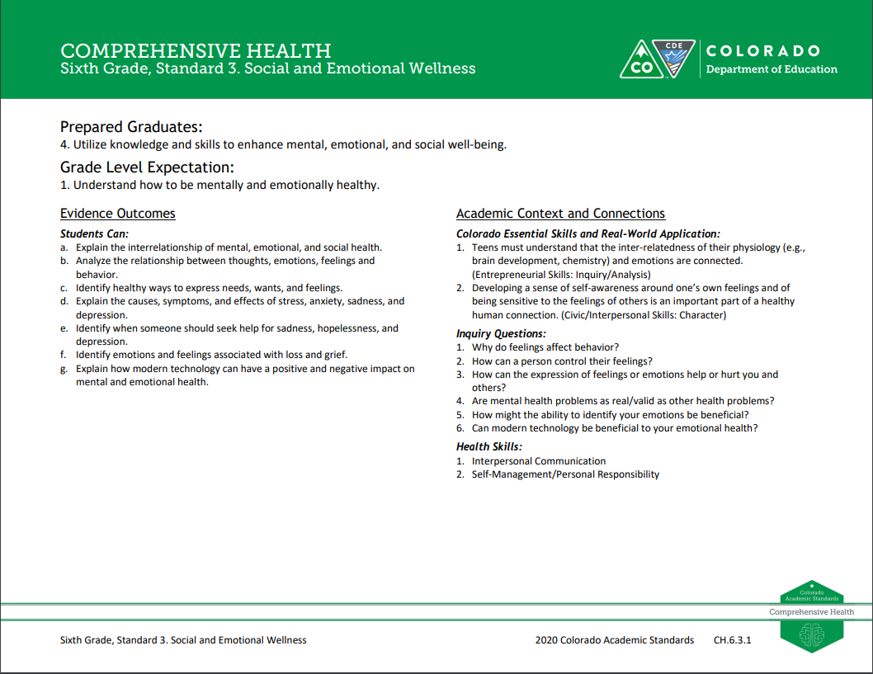
The 2009/2010 Colorado Academic Standards introduced seven Prepared Graduate Competencies (PGC) in health education. These seven PGC’s highlighted the preschool through twelfth-grade concepts and skills that all students should master to ensure success in a postsecondary and workforce setting. In the 2018 revision, the term Prepared Graduate Competencies was changed to Prepared Graduate Statements. Revision to Prepared Graduate Competency: Apply knowledge and skills to make health-enhancing decisions regarding the use of alcohol, tobacco, and other drugs was revised to read: Demonstrate the ability to make good decisions about drug use marijuana, illegal drugs, prescription drugs, alcohol, and tobacco. It is important to note that local data and students’ needs should drive the focus of health education at the local level. With constantly changing health concerns regarding behaviors and drug use, it is up to the local communities to address their specific local needs regarding priority behaviors and drug use. The standards related to drug use prevention are intended to guide specific skills regarding the prevention of drug use. The specific drugs identified in the standards are not limiting, prioritized, or, comprehensive, and local schools and districts should identify their areas of focus based on local data and student needs.
2018 Health Education Standard
In addition, the committee aligned all Prepared Graduate Statements and Grade Level Expectations to span across grade levels preschool through twelfth-grade. This insures that students gain consistency of instruction that focus on essential health skills from one grade to the next. Any changes made were to add specificity and clarity, not to fundamentally change what students are expected to know and be able to do. The social emotional wellness standard was expanded at the preschool and early elementary level as well as at most grade levels. In some cases grade level expectations shifted to other grades for better alignment and to fill in gaps. For example healthy eating was added to 8th grade as a new grade level expectation.

Adjustments to Right Side of the Document
The 2009/2010 health education standards have a section titled “21st Century Skills” which house inquiry questions, relevance and application statements, and nature of health elements. The 2020 health standards have re-titled this section to be, “Academic Content and Conenctions.”
2018 Health Education Standard
The first component of this section is the “Colorado Essential Skills and Real World Application.” This area highlights the skills and practices that students will be using while mastering the concepts and skills within the grade level expectations and evidence outcomes.
2018 Health Education Standard
The review and revision committee kept the Inquiry Questions subsection from 2009/2010. The committee designed revised questions to prompt deeper thinking about the health education content described by the grade level expectations and evidence outcomes.
Another component of this section is the addition of “Health Skills” section replacing the 2009/2010 subsection “Nature of Health”. This section identifies the key health skills aligned with the National Health Education Standards. Cross cutting health skills include analyzing influences, accessing information, interpersonal communication, decision-making, goal setting, self-management, and advocacy for self and others. These cross cutting skills have application across all topical/domains of health education. As such, they are a way of linking the different topical areas/domains of health with core health skills. These health skills were identified based on the grade level expectation and the evidence outcomes. They represent the key health skill or in some cases multiple skills for each grade level expectation.
2018 Health Education Standard

Preschool and Early Elementary
The review and revision committee’s preschool revisions are a significant change compared to the 2009/2010 standards, but a minor adjustment when compared with CDE’s 2013 Early Learning Development Guidelines. A major focus in Preschool and Early Elementary focused on the development of social emotional skills.

