Name: ___________________________________ Date: ______________

Standards Implementation
Module 10: Mind the Gap

Goals & Objectives:
In Modules 8 and 9, you made sense of the standards and mapped them to your curriculum. In this module, you will:
- Combine your understandings of the standards and your curriculum to identify gaps and overlaps in your curriculum.
- Work with other educators to understand why gaps and overlaps exist.

Disciplinary Literacy:
- Close Reading
- Speaking for understanding in content-areas
- Writing in discipline-specific ways

I. Introduction:

Define “Gaps” | Define “Overlaps”

II. Four Types of Conversations: Looking for Gaps and Overlaps

 | Within Grade | Across Grades
Within Content Areas |  | 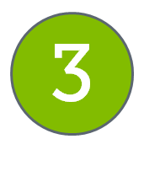
Across Content Areas | 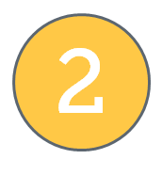 | 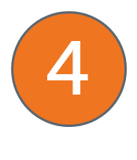

Guiding Questions to Find Gaps:
- What was highlighted red and yellow?
- Do we really not cover it in this content area? Why not?

Guiding Questions to Find Overlaps:
- When we were highlighting things green in Module 9, what felt like it might be too green? In other words, did you have thoughts like:
- “We spend a month on factoring quadratics. Is that a lot?”
- “Of course I teach the Civil War! We take five weeks to watch and study the entire PBS documentary.”
- “I teach a lot of this because it’s fun, but it’s not really in the standards.”

Gaps: | Overlaps:
Guiding Questions to Find Gaps:
- Are the things that got highlighted red and yellow not covered under a different content area? Why not?

Guiding Questions to Find Overlaps:
- When we were highlighting things green in Module 9, what could have been highlighted green by multiple content areas? For example:
- Is scientific notation being taught by both the science teacher and the math teacher?
- Are there texts being studied in social studies classes that address standards in Reading, Writing, and Communicating?

Gaps: | Overlaps:

Guiding Questions to Find Gaps:
- Did anything get highlighted red or yellow because you think it’s taught in another grade? Why did you think that?

Guiding Questions to Find Overlaps:
- When we were highlighting things green in Module 9, what could have been highlighted green by teachers of multiple grade levels?
- If you are teaching something described by the standards of a previous or future grade, why are you doing it?
- Instead of moving some students faster (into the next grade), where can we go deeper?

Gaps: | Overlaps:
Guiding Questions to Find Gaps:
- Did anything get highlighted red or yellow because you think it’s taught in another grade in a different content area? Why did you think that?

Guiding Questions to Find Overlaps:
- When we were highlighting things green in Module 8, what could have been highlighted green by teachers of other grade levels in other content areas?
- If you are teaching something described by the standards of a previous or future grade, and/or another content area, why are you doing it?

Gaps: | Overlaps:

