Name: _____________________________ Date: _________________

Standards Implementation
Disciplinary Literacy: It’s Not Rocket Science!

Goals & Objectives:
Educators will be able to demonstrate, through writing and discussion, their understanding of following:
- The definition of disciplinary literacy;
- The importance of disciplinary literacy; and,
- How disciplinary literacy is fundamental to standards literacy for all educators.

Disciplinary Literacy Strategies:
- “Writing in discipline-specific ways”
- Speaking for understanding in content-areas
- Close reading

I. Warm-Up: Writing for Discussion:
In the space provided, write your response to the following question:
- What is disciplinary literacy?
______________________________________________________________________________________________________________________________________________________________________________________________________________________________________________________________________________
__________________________________________________________________________________________
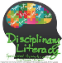
II. What is Disciplinary Literacy?
Use the chart below to capture notes, ideas, wonderings, and takeaways regarding disciplinary literacy.
Definition: (Denotation)
______________________________________________________________________________________________________________________________________________________________________________________________________________________________________________________________________________
Article Takeaways: (“What is Disciplinary Literacy? Why Does it Matter” Tim & Cynthia Shanahan) | Video Notes:
III. Why Disciplinary Literacy?
1. What does it mean to read, write, think, and communicate like a ________________?
_______________________________________________________________________________________________________________________________________________________________________________________________________________________________________________________________________________________________________________________________________________________________________________________________________________________________________________________________________________________________________________________________________________________________________________________

IV. What are similarities and differences between you and your colleague’s response to question #1?
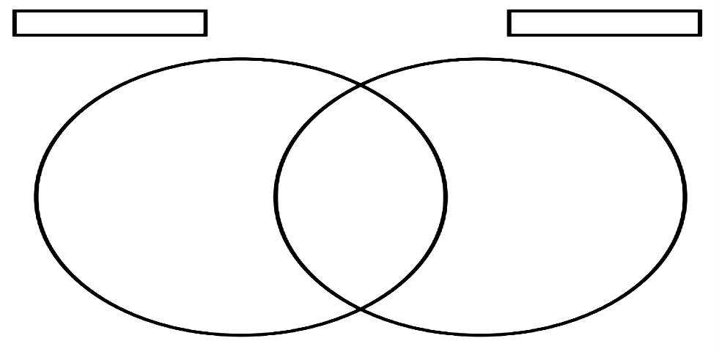

V. How does knowing what literacy looks like in your colleague’s discipline help inform your understanding and/or practice of disciplinary literacy?
_____________________________________________________________________________________________________________________________________________________________________________________________________________________________________________________________________________________________________________________________________________________________________________________________________________________

Additional Notes:

VI. How is Disciplinary Literacy Fundamental to Standards Literacy?
Notes:

Assessment: Using your notes, craft a one paragraph elevator speech that answers the following questions:
- What is disciplinary literacy?
- Why disciplinary literacy?
- How is disciplinary literacy fundamental to standards literacy for all educators?

Elevator Speech: | 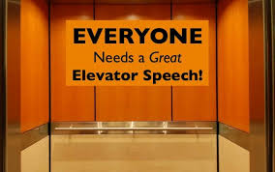

Practice, Practice, Practice!
Find a colleague that teaches the same discipline and read your elevator speech to him/her. If the elevator speech answers all the three questions, give him/her a handshake. If not, bid him/her adieu with a wave and motion of the elevator closing.

