Name: _____________________________ Date: _________________

Standards Implementation
Module #4: The Highlights!

Goals & Objectives:
Educators will be able to demonstrate, by comparing and contrasting the 2009/2010 CAS and the 2020 CAS, their understanding of the following:
- The similarities and differences between the 2009/2010 and the 2020 CAS at a high level;
- The organization of the standards framework; and,
- Why revisions were made.

Disciplinary Literacy Strategies:
- “Writing in discipline-specific ways”
- Speaking for understanding in content-areas
- Close reading

I. What is the difference between the 2009/2010 and 2020 standards?
Using the provided standards documents, provide 3 similarities and 3 differences between the versions.

Similarities: | Differences:
Observations

II. CAS Framework: Quick Walk Through Notes _____________________________________________________________________________________________________________________________________________________________________________________________________________________________________________________________________________________________________________________________________________________________________________________________________________________

III. Fill in the blanks

Select the correct label for each sections of the standards document using the following options: Academic Context and Connections, Prepared Graduates, Grade Level Expectation, Evidence Outcomes

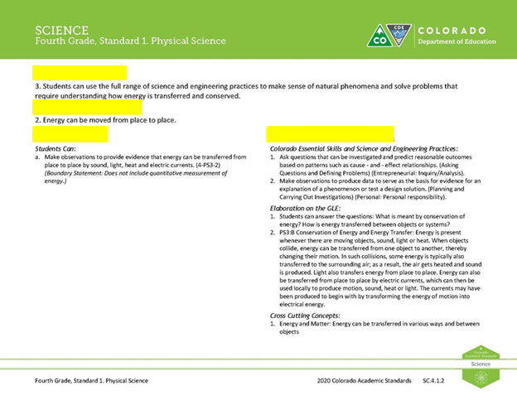
IV. Standards Online System Notes _____________________________________________________________________________________________________________________________________________________________________________________________________________________________________________________________________________________________________________________________________________________________________________________________________________________

V. Interaction with the Online Standards System
- Go to the CDE website link, http://www.cde.state.co.us/standardsandinstruction
- Bookmark the Office of Standards and Instructional Support Page
- Take 5 minutes to interact with your content area standards.

Additional Notes:

Assessment: Using your notes, craft a one paragraph elevator speech that answers the following questions:
- What are the differences between the 2009/2010 and 2020 standards?
- What is the organization of the standards framework?
- Why were revisions made to the academic standards?

Elevator Speech: | 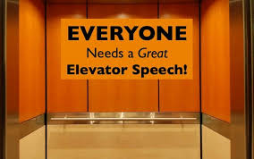

Practice, Practice, Practice!
Find a colleague that teaches the same discipline and read your elevator speech to him/her. If the elevator speech answers all the three questions, give him/her a handshake. If not, bid him/her adieu with a wave and motion of the elevator closing.

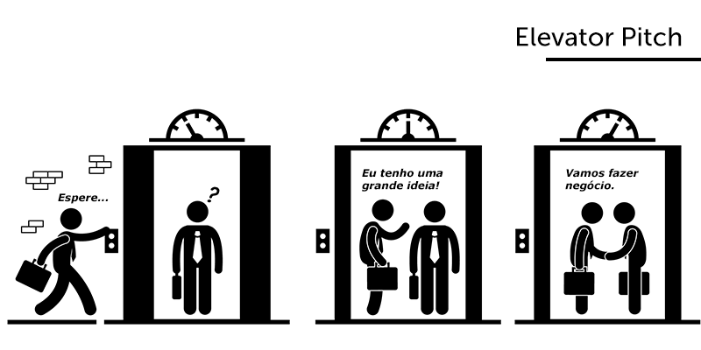

Reflection:

