Name: _____________________________ Date: _________________

Standards Implementation
The Birds and Bees of Colorado Academic Standards
Goals & Objectives:
Educators will be able to demonstrate, through writing and discussion, their understanding of following:
- Provide an overview of the standards review and revision process
- Review the high level plan for implementation support

Disciplinary Literacy Strategies:
- Reading from the lens/perspective of the subject/content area
- Speaking for understanding in the content area

I. History of CAP4K & CAS: Fill in the year of each CAP4K or CAS update in the following table
YEAR | CAP4K & CAS EVENTS
 | CAP4K passes; school readiness and postsecondary workforce readiness defined by the State Board of Education
 | Standards revision process conducted; new standards adopted in all ten content areas (called the Colorado Academic Standards)
 | Standards in mathematics and English/language arts adopted; standards in these two content areas reissued
 | Transition process to new standards and assessments
 | Full implementation of standards and continued transition to new assessment system
 | The first review and revision cycle for the Colorado Academic Standards is set to conclude (and every six years thereafter)

II. CAS Revision Process & Timeline

III. Standards Review and Revision Roles and Responsibilities

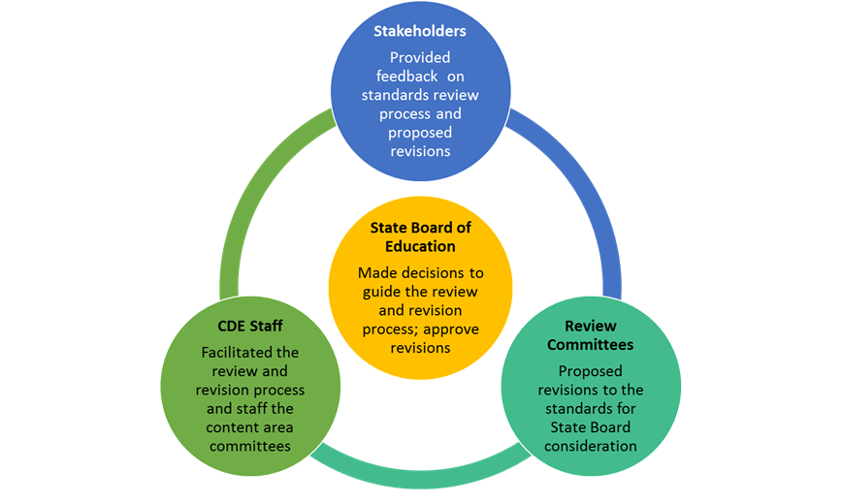

IV. Standards Final Approval

V. Implementation Timeline

Assessment: After learning about the Colorado Academic Standards review and revision process, why do you think periodic review and revision of academic standards is important? What is your level of comfort with implementing updated standards in your content area? What school year are you responsible for full implementation of the new standards?
_______________________________________________________________________________________________________________________________________________________________________________________________________________________________________________________________________________________________________________________________________________________________________________________________________________________________________________________________________________________________________________________________________________________________________________________
_____________________________________________________________________________________________________________________________________________________________________________________________________________________________________________________________________________________________________________________________________________________________________________________________________________________

