Name: ____________________________________ Date: ________________

Standards Implementation
Module 11: Bridging the Gaps

Goals & Objectives:
Educators will be able to, both in writing and through discussion:
- Create an ideal vision of aligning curriculum and standards in your classroom and/or school.
- Revisit gaps that exist and consider available curriculum resources, time allocation for each content area, and any additional solutions to eliminate gaps.
- Create a proposed plan of action to successfully implement the 2020 Colorado Academic Standards and close gaps.

I. Warm-Up:
Take 2 minutes to imagine the following. Without considering time or money as limitations, what would an ideal standards aligned curriculum look like for your classroom or school?

Ideal Standards Aligned Curriculum and Instruction is...

II. Activity: Compare and Contrast Ideal to Current:
In a group, share warm-up responses and compare and contrast the vision for ideal curriculum to what you currently teach. Are there overlaps? Is the ideal curriculum far away from what you are currently teaching?

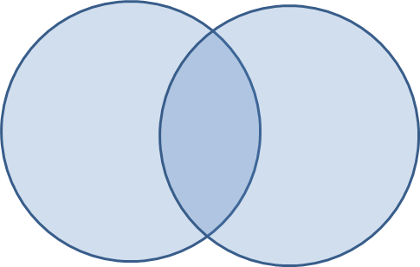

III. Creating a Proposal

Gap Plan

Content and Grade:

Submitted by:

Description of Gap:

Summary of Plan for Addressing Gap:

Detailed Needs:

Collaborations:

Materials (include $ estimate, if known):

Professional Development (include time and $ estimate, if known):

Implementation Timeline (Quick wins? Long-term needs?):

Who is Responsible?

Other Considerations or Suggestions:

