Name: _____________________________ Date: _________________

Standards Implementation
Module #5: A Whole New Level

Goals & Objectives:
Educators will be able to demonstrate, through writing and discussion, their understanding of following:
- The concepts, content, and skills within a standards document;
- How those components are explicitly linked; and,
- The importance of reading the standards closely.

Disciplinary Literacy Strategies:
- “Writing in discipline-specific ways.”
- Speaking for understanding in content-areas.
- Close reading

I. What is the difference between concepts, content and skills? Provide examples from the science standards document.
CONCEPTS: | CONTENT: | SKILLS:
Wonderings:

II. Where do you see connections to Disciplinary Literacy?
________________________________________________________________________________________________________________________________________________________________________________________________________________________________________________________________________________________________________________________________________________________________________________________________________________________________________________________________________________________________________________________________________________________________________________________________________________________________________________________________________

III. What are similarities and differences between you and your colleague’s response to question I?
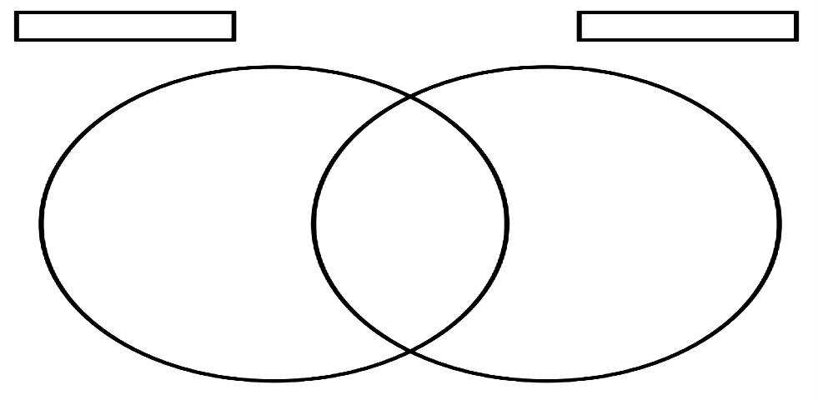

IV. What are the main takeaways from the close read of the standards?
______________________________________________________________________________________________________________________________________________________________________________________________________________________________________________________________________________________________________________________________________________________________________________________________________________________________________________________________________________________________________

Additional Notes:

V. How do you envision incorporating the whole standards document into your curricular planning?
Notes:

Assessment: Using your notes, craft a one paragraph elevator speech that answers the following questions:
- What are the standards asking students to understand, know, and be able to do?
- How do the standards connect these together?

Elevator Speech: | 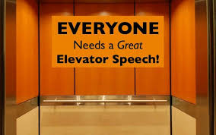

Practice, Practice, Practice!
Find a colleague that teaches the same discipline and read your elevator speech to him/her. If the elevator speech answers all the questions, give him/her a handshake. If not, bid him/her adieu with a wave and motion of the elevator closing.

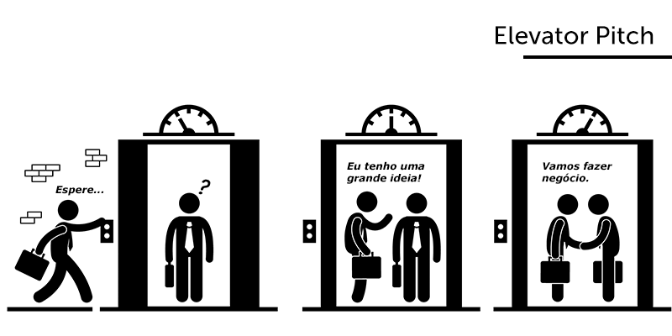

Reflection:

